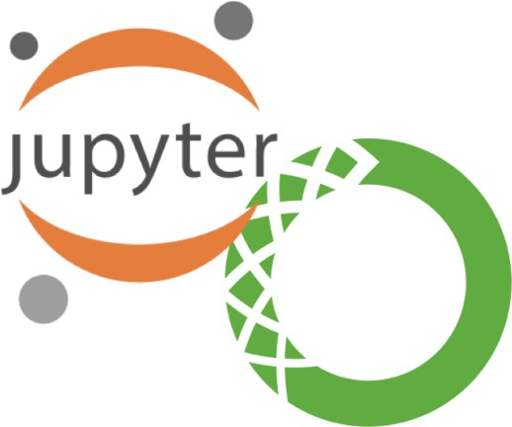
Quick Guide to Installing and Setting Up MySQL Workbench

Pre-Installation Information

What is Python?
- Python is an interpreted, high-level, general-purpose programming language.
- Python supports the use of modules and packages, which means that programs can be designed in a modular style and code can be reused across a variety of projects. Once you've developed a module or package you need, it can be scaled for use in other projects, and it's easy to import or export these modules.

What is Jupyter Notebook?
- The Jupyter Notebook is an open-source web application that allows you to create and share documents that contain live code, equations, visualizations and narrative text.
- Jupyter Notebooks are a powerful way to write and iterate on your Python code for data analysis. Rather than writing and re-writing an entire program, you can write lines of code and run them one at a time.

What is Anaconda?
- Anaconda is a free and open-source distribution of the Python and R programming languages for scientific computing, that aims to simplify package management and deployment.

Part I. Installing and Setting Up MySQL Workbench
Windows Users:
  - Go to this link to download Anaconda: https://www.anaconda.com/distribution/, press on
“Download” and double click the exe file.
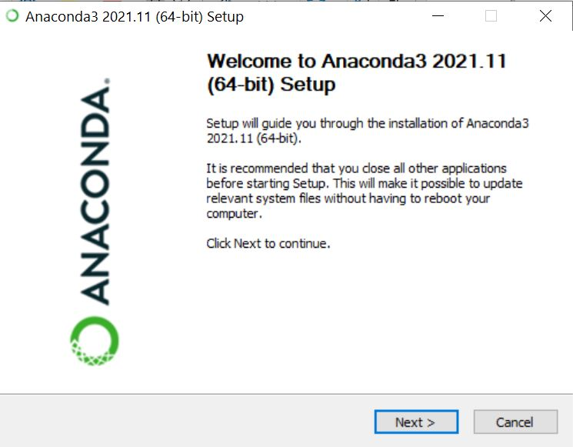
  - Click “I Agree” to continue
  - Choose “Just Me (recommended)” so that the software will only be installed for your account on the computer only. Click “Next” to continue.
  - The installation will ask for a Destination Folder to install the software. Keep the default value
and click “Next”
  - In the Advanced Options, keep all the options as default, then press “Install”
  - Depending on your computer, this process could take up to 5 minutes

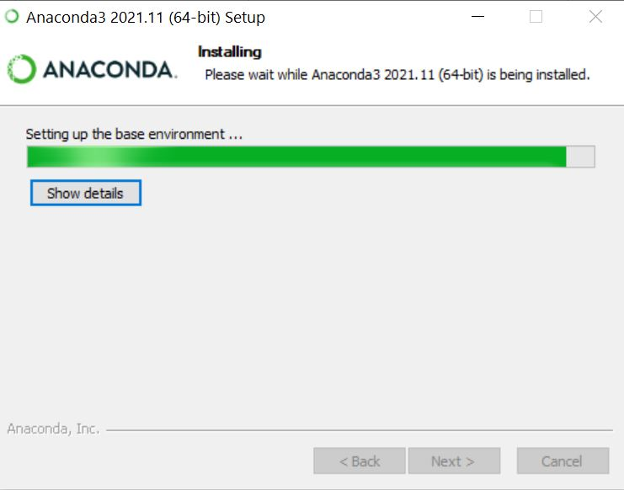
  - Open Anaconda and click ‘launch’ under Jupyter notebook.
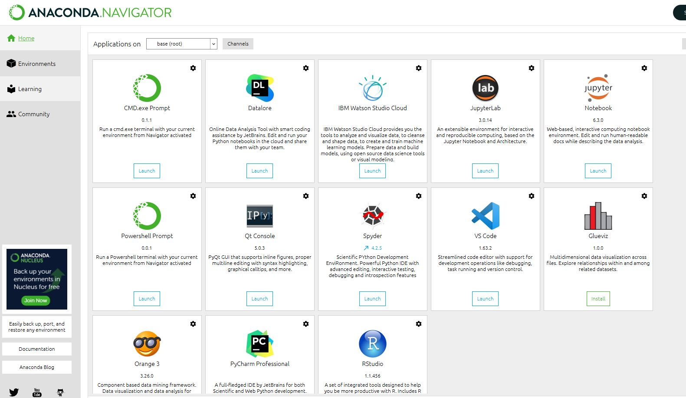
  - If your default internet browser does not turn on by itself, directly search for Jupyter Notebook and run the program

  - Or else, if everything is working well, you will see something like this, meaning that Anaconda is successfully installed, as well as your Jupyter Notebook!
