In-class Activity #4: Working with SQL, Part 2
Getting Information out of a Database
Submission Instructions
Submit your solutions for Part 2 of this exercise as a word or pdf file through Canvas>Assignments>To-Do.

To do this exercise, you will be working with a movie rental database. The schema for this database is provided on the accompanying document. All of the tables are in a schema called simply “moviedb” (not m0moviedb, m1moviedb, etc.). You can’t write to any of the tables – you can only use SELECT statements to read from them (so don’t worry about causing any damage).
Spend some time looking at the schema carefully. The field names are pretty self-explanatory. For example, here are three tables:
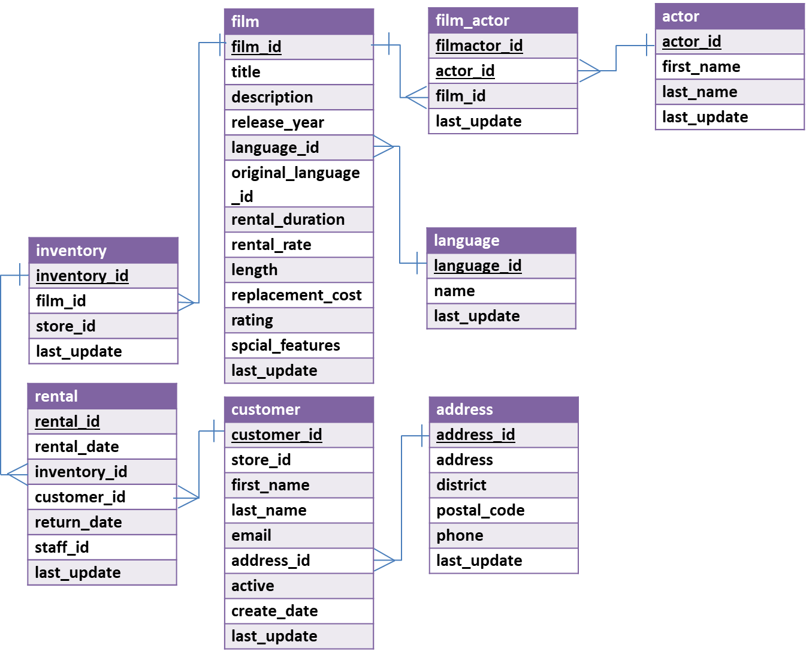
You can see that a film has a title, description, rating, and length (among other things). You can also see that an actor has a first name and a last name. The film_actor table implements the many-to-many relationship between actor and film (i.e., a film can have more than one actor, and an actor can be in more than one film). You’ll also notice that data types are listed for each field, but they should be pretty obvious – for example, first_name is a VARCHAR because it is a string value.
Part 1: Try out some queries
- A “subselect” statement
Finally, let’s do a query with a subselect:
SELECT title, replacement_cost
FROM moviedb.film
WHERE replacement_cost = (SELECT MAX(replacement_cost)
FROM moviedb.film);
This will return movies with the highest replacement cost (there are 53 of them), here’s the first few:
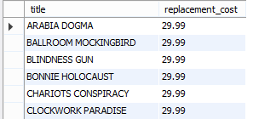
Here’s what’s going on:
SELECT title, replacement_cost  FROM moviedb.film | SELECTing the title and replacement cost of the movies from our film table
WHERE replacement_cost = | Filtering based on replacement cost. We only want the movies where the cost is equal to its highest value
(SELECT MAX(replacement_cost)  FROM moviedb.film) | We get the highest value with another SELECT statement that gets the MAXimum replacement cost from the film table
Part 2: Write queries on your own (Submit your solutions for Part 2 only on Canvas)
Create the SQL SELECT query to answer each of the questions below. Some of the questions can be answered by querying one table; others will require joining multiple tables to get the answer.
For each question you’ll need to write down (1) the SQL query (which you can copy and paste it from SQL Workbench) and (2) the answer you get as a result of the query (which you can copy and paste from the results).
- What is the title and length of the longest movie in the database? Assume there could be more than one movie with the longest value and use a subselect with the MAX() function to find the movies with the greatest length.
Display: title and length
(Hint: You should not use LIMIT as below as there can be more than one movie with the same longest value:
SELECT title, length
FROM moviedb.film
ORDER BY length DESC LIMIT 1;)

- In which films did Sandra Peck star (only return the first five)?
Display: title

- How many times has the customer Adam Gooch rented?
Display: number of movies
(HINT: You need to use the customer table and the rental table.)

- What is the two most popular first names of customers who live in postal code greater than 40000?
Display: first name and the number of first names

- What’s the longest film among inventories in store 2?
(HINT: Use store_id column.)
Display: title

- What's the most expensive (in terms of rental rate) film by Penelope Guiness? And what is the rental rate?
Display: title and rental rate

- How many different ratings are there in Film table?
Display: number of different ratings

ANSWER SHEET
Question |  | SQL Query | Results/Answer from MySQL Workbench
1 | What is the title and length of the longest movie in the database? Assume there could be more than one movie with the longest value.
2 | In which films did Sandra Peck star (only return the first five)?
3 | How many times has the customer Adam Gooch rented?
4 | What is the two most common first names of customers who live in postal code greater than 40000?
5 | What’s the longest film among inventories in store 2?
6 | What's the most expensive (in terms of rental rate) film by Penelope Guiness? And what is the rental rate?
7 | How many different ratings are there in Film table?

