ICA #8: Data Visualization Principles

Submit your solutions as a word or excel file through Canvas>Assignments>To-Do Submissions. Deliverables from in-class activities will be graded by success or fail based on completeness.
The submission should include the following for each chart:
- Evaluation of each chart using the data visualization principles presented earlier (i.e., ability to tell a story, graphical integrity, minimize graphical complexity, etc.).
- Improved chart created from excel. You can do anything you’d like to the charts, and you can also create additional charts if you think that is necessary. Also provide some note/description here too, justifying what you’ve done.

You’ve been asked to work for the headquarters of DS’s Fine Foods Emporium. After gaining a new appreciation of the potential for using business analytics in their organization, they ask you to help them communicate the results of their analysis. They have already put together a dashboard (see figure below), but management found it confusing; so confusing, in fact, that they started questioning the analysis itself.
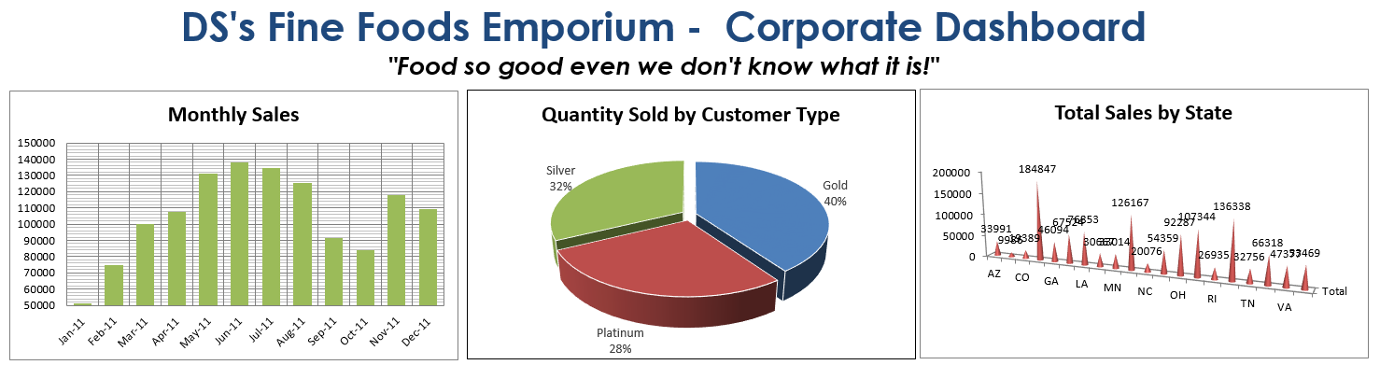
Download the “Food-Emporium_Dashboard.xlsx” file from the course site.
The dashboard is a worksheet (“Dashboard”) in the file. The underlying pivot tables are on the “Pivot Tables” sheet and are still linked to the charts. Your task is to re-examine each one of the three charts and make improvements to the charts.

