Assignment #3: SQL Part 2 – Advanced Queries

Submission Instructions
Due: Friday, 2/17/2023, 11:59 pm
- Complete and submit the answer sheet on page 3 as a word or PDF document through Canvas>Assignments>To-Do.
- You can copy and paste the (i) SQL query and (ii) the results from SQL Workbench.
Evaluation
Your submission will be graded using two factors:
- A correctly formed SQL query that answers the specific question asked (no extra rows or columns).
- Providing the correct answer to the question (the results returned from MySQL Workbench).

For this assignment, you will be working with the movie rental database, named as “moviedb”.
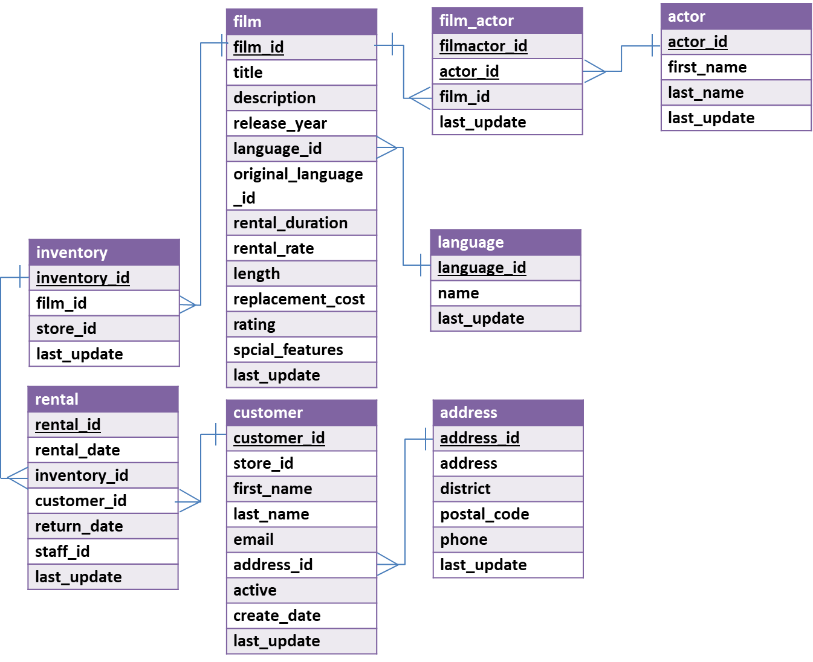

Questions
- How many times has each language been used in films? Return the value for all six languages.
Display: language name and the number of films

- How many actors stared in the film titled “BREAKING HOME”?
Display: number of actors

- Who has rented movies in Japanese language? Return only the first five distinct results in alphabetical order by last name.
(Hints: In the language table, there is a field “name” that contains the film language names.)
Display: first name and last name

- How many different last names exist in the customer table?
Display: number of unique last names

- Who has rented the most movies? How many rentals did s/he do?
(Hint: Assume no ties - there’s only one customer with the highest value.)
Display: first name, last name and number of rentals

- Which are the languages of the movies that Tom Miranda has acted and how many films has he acted in each of those languages?
Display: language and number of languages

- What is (are) the PG-rated movie(s) with the largest replacement cost at store 2? And how much is it (are they)?
(Hint #1. PG-rated movies have rating value equal to ‘PG’;
Hint #2. Use store_id in the Inventory table;
Hint #3. There may be more than one movie returned.)
Display: movie title and replacement cost

- What is (are) the title(s) and the rental rate of the movie(s) that has (have) the least expensive rental rate among movies acted by Emily Dee?
(Hint: There can be more than one movie)
Display: movie title, rating, and rental rate

- (Bonus question-optional) What is the average of the average rental rate for each movie rating?
(Hint: Find out the average rental rate of each rating and then compute the average of those numbers)
Display: average of the average rental rate per rating
(The bonus points will be added to your final grade of this assignment. There will be no partial credit for this question.)

ANSWER SHEET
Assignment #3: SQL Part 2 - Getting Data out of the Database
Question |  | SQL Query | Results/Answer from MySQL Workbench
1 | How many times has each language been used in films? Return the value for all six languages.
2 | How many actors stared in the film titled “BREAKING HOME”?
3 | Who has rented movies in Japanese language? Return only the first five distinct results in alphabetical order by last name.
4 | How many different last names exist in the customer table?
5 | Who has rented the most movies? How many rentals did s/he do?
6 | Which are the languages of the movies that Tom Miranda has acted and how many films has he acted in each of those languages?
7 | What is (are) the PG-rated movie(s) with the largest replacement cost at store 2? And how much is it (are they)?
8 | What is (are) the title(s) and the rental rate of the movie(s) that has (have) the least expensive rental rate among movies acted by Emily Dee?
9 | (optional) What is the average of the average rental rate for each movie rating?

