Assignment #4: NoSQL Part 1
Submission Instructions
Due: Friday, 3/17/2023 at 11:59 pm
- Submit your solutions as a Word or PDF file through Canvas>Assignments>To-Do.
- If you do not follow the instructions, your assignment will be counted late.

Evaluation
- Your submission will be graded based on two factors:
- A correctly formed NoSQL query that answers the specific question asked (no extra rows or columns).
- Providing the correct answer to the question (the results returned from MongoDB Compass).

Here is an example of what a document in this collection looks like (JSON Pretty Print):
Restaurantdb.restaurant

{
"_id": {
"$oid": "5eb3d668b31de5d588f4292d"
},
"address": {
"building": "469",
"coord": [-73.961704, 40.662942],
"street": "Flatbush Avenue",
"zipcode": "11225"
},
"borough": "Brooklyn",
"cuisine": "Hamburgers",
"employee": 4,
"year": 1820,
"option": ["Delivery", "Drive-through", "Takeout", "Dine-in"]
}

Here is how to view the MongoDB code for an aggregation pipeline:
- Connect to the server on MongoDB Compass.
- Open the database and collection and click on the aggregations tab.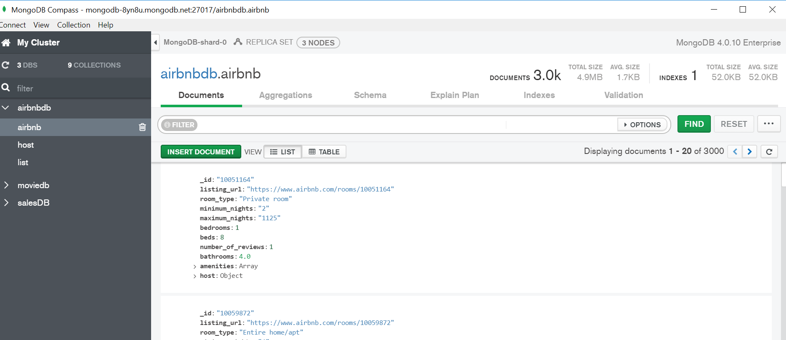
- After creating your pipeline by adding stages, click “Export Pipeline to Language”.
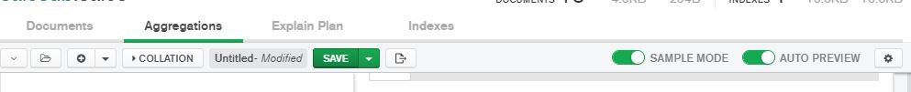

- The text shown in the left box is the MongoDB code for the last pipeline you created.
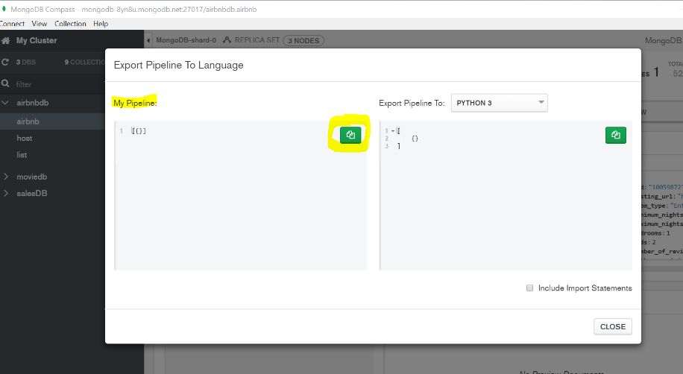
Instructions:
Use MongoDB Compass and open restaurant collection in the RestaurantDB database to answer the questions below. Include the query used (make sure to include all stages) and the results of the query.
Question | Query Used | Answer
- How many “Irish” restaurants are opened in 2003?
- Return the number of employees and the opening year of “German” restaurants.
- Return the borough, cuisine, and the opening year of two restaurants with the highest number of employees.
- What is the average number of employees of restaurants in each opening year? Only return the year and the average number of employees of the smallest average number. |  | (Round the query result to two decimal places)
- Return the highest number of employees among the restaurants that were opened in 2003.
- Return the cuisine, employee, and opening year of the most recently opened “Irish” restaurant that has less than 7 employees.

- What is the equivalent SQL code for the query you found in question 2?

- What is the equivalent SQL code for the query you found in question 6?

