In-Class Activity #7: NoSQL Part 2

Submission Instructions
Submit your solutions as a Word or PDF file through Canvas>Assignments>To-Do Submissions.
Use MongoDB Compass and open airbnb collection in the airbnbDB. Uses the to answer the questions below.
Here is an example of what a document in this collection looks like (JSON Pretty Print):
Airbnbdb.airbnb

{
"_id": "25167125",
"listing_url": "https://www.airbnb.com/rooms/25167125",
"room_type": "Private room",
"minimum_nights": "1",
"maximum_nights": "1125",
"bedrooms": 1,
"beds": 1,
"number_of_reviews": 11,
"bathrooms": {
"$numberDecimal": "1.0"
},
"amenities": [
"Wifi",
"Air conditioning",
"Kitchen",
"Free parking on premises",
"Pets allowed",
"Breakfast",
"Free street parking",
"Heating",
"Smoke detector",
"First aid kit",
"Essentials",
"Shampoo",
"Hangers",
"Laptop friendly workspace",
"Private entrance",
"Bed linens",
"Extra pillows and blankets",
"Luggage dropoff allowed",
"Cleaning before checkout",
"Disabled parking spot",
"Accessible-height bed",
"Host greets you"
],
"host": {
"host_id": "11490944",
"host_url": "https://www.airbnb.com/users/show/11490944",
"host_name": "Rachelle",
"host_location": "Montreal, Quebec, Canada",
"host_about": "I am a traveler at heart and free spirit. I love people and enjoy their company. I am happy to help with anything I can. \r\nYou are welcome in my home.\r\nI promise that you will enjoy your stay.\r\nLiving Free!",
"host_response_time": "within an hour",
"host_thumbnail_url": "https://a0.muscache.com/im/pictures/b07f65b1-5ad0-4570-b489-3a6ecf66a40e.jpg?aki_policy=profile_small",
"host_picture_url": "https://a0.muscache.com/im/pictures/b07f65b1-5ad0-4570-b489-3a6ecf66a40e.jpg?aki_policy=profile_x_medium",
"host_neighbourhood": "Dorval",
"host_response_rate": 100,
"host_is_superhost": false,
"host_has_profile_pic": true,
"host_identity_verified": false,
"host_listings_count": 3,
"host_total_listings_count": 3,
"host_verifications": [
"email",
"phone",
"reviews",
"jumio",
"offline_government_id",
"selfie",
"government_id",
"identity_manual"
]
}
}
Here is how to view the MongoDB code for an aggregation pipeline:
- Connect to the server on MongoDB Compass.
- Open the database and collection and click on the aggregations tab.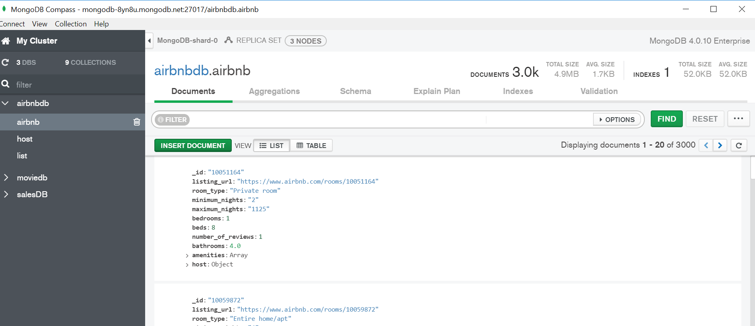
- After creating your pipeline by adding stages, click “Export Pipeline to Language”.
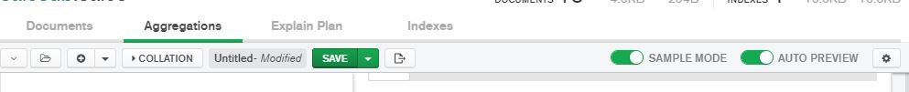

- The text shown in the left box is the MongoDB code for the last pipeline you created.
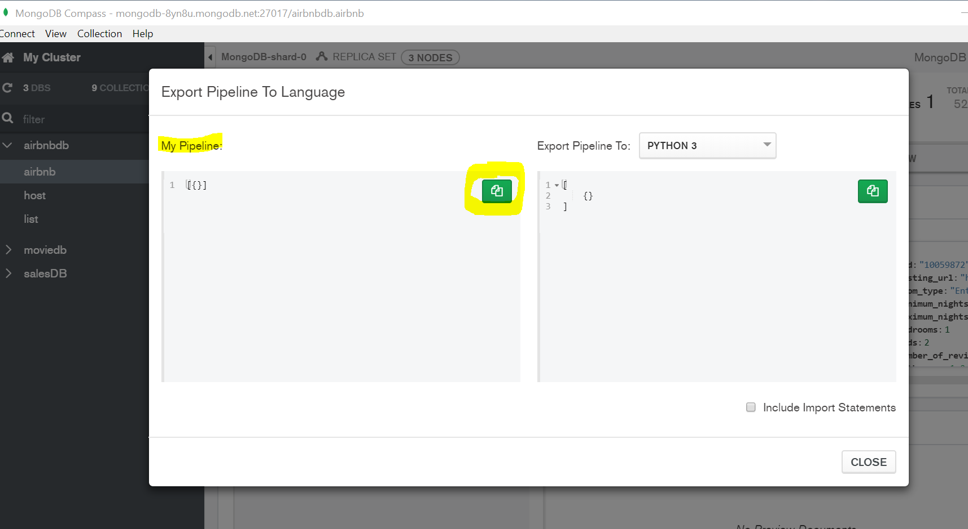
Instructions:
Use MongoDB Compass and open the airbnbDB. Uses the airbnb collection to answer the questions below. Include the query used and the results of the query. (MongoDB Compass is case sensitive).
- Return the id and room type of the accommodations where the host id is 2279116 and the host name is Andy. (hint: host id and name are recorded as string)
Query:

Query Result:

- Return the id, host name, and host id of the accommodation that has the highest "host_total_listings_count". Return only the first result.
Query:

Query Result:

- What is the average host response rate grouped by room type?
(hint: use "host_response_rate")
Query:

Query Result:
Round results to the first decimal point.
- How many accommodations include the amenities of "Air conditioning" and an "Elevator"?
Query:
Query Result:
- How many accommodations have 40 amenities?
Query:

Query Result:

- How many accommodations have a 99(%) of host response rate and include amenities of a "Lockbox" and a "Dryer"?
Query:

Query Result:

Use the list collection to answer question 7.
- What is the query to join the host connection to the list connection, in order to bring the host information to the list collection?
Query:

