Quick Guide to Installing and Setting Up MySQL Workbench
Click here to start installing MySQL Workbench on your own computer:
Go to: https://dev.mysql.com/downloads/workbench/
For Mac instructions, skip from here to page 3.
Part I. Installing and Setting Up MySQL Workbench
Windows Users:
- Prerequisites: You may have to install the Microsoft .NET Framework 4.5 and the Visual C++ Redistributable for Visual Studio 2015. This has some basic software that MySQL Workbench needs to run. There are instructions for how to get this software under “MySQL Workbench Prerequisites.” You can go to this page by clicking on the “i” tab next to Archives. My suggestion is that you run the installation below, and only install the prerequisites if you are told to.

- Select “Microsoft Windows” from the “Select Platform” drop-down menu. Under “Other Downloads”, you’ll see the download option (as below).

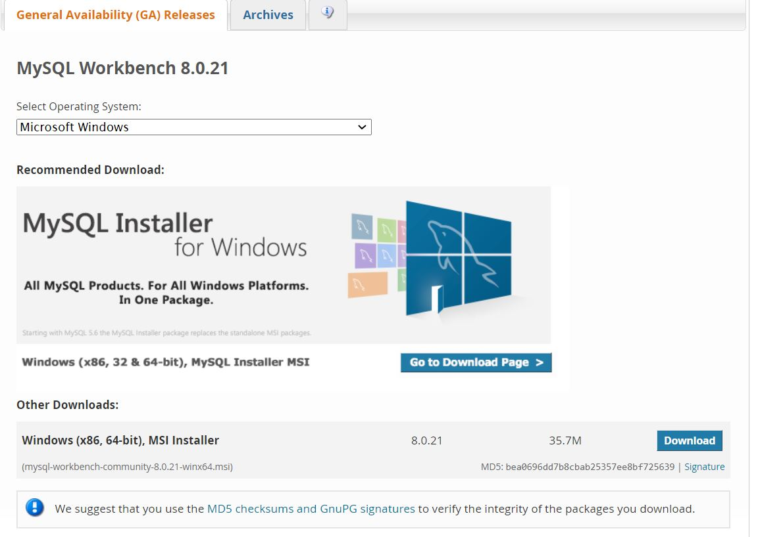

- At the “Begin Your Download” page, it may ask you to login or sign up for a free account (see a screenshot on next page). Do not worry about it, just click on “No thanks, just start my download” at the end of the page.
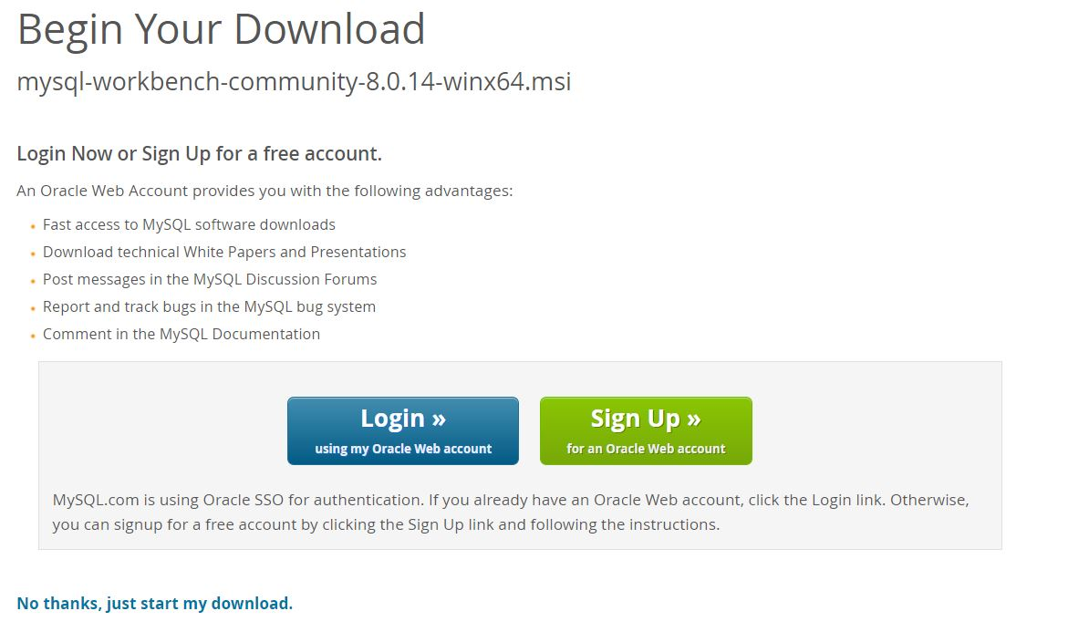

- After the installer is downloaded, double-click on the installer to install the software.

- Keep on clicking “Next” until you can click “Install” to install the software.

- Click “Finish” when you are done. MySQL Workbench will open, and you will see the following window:
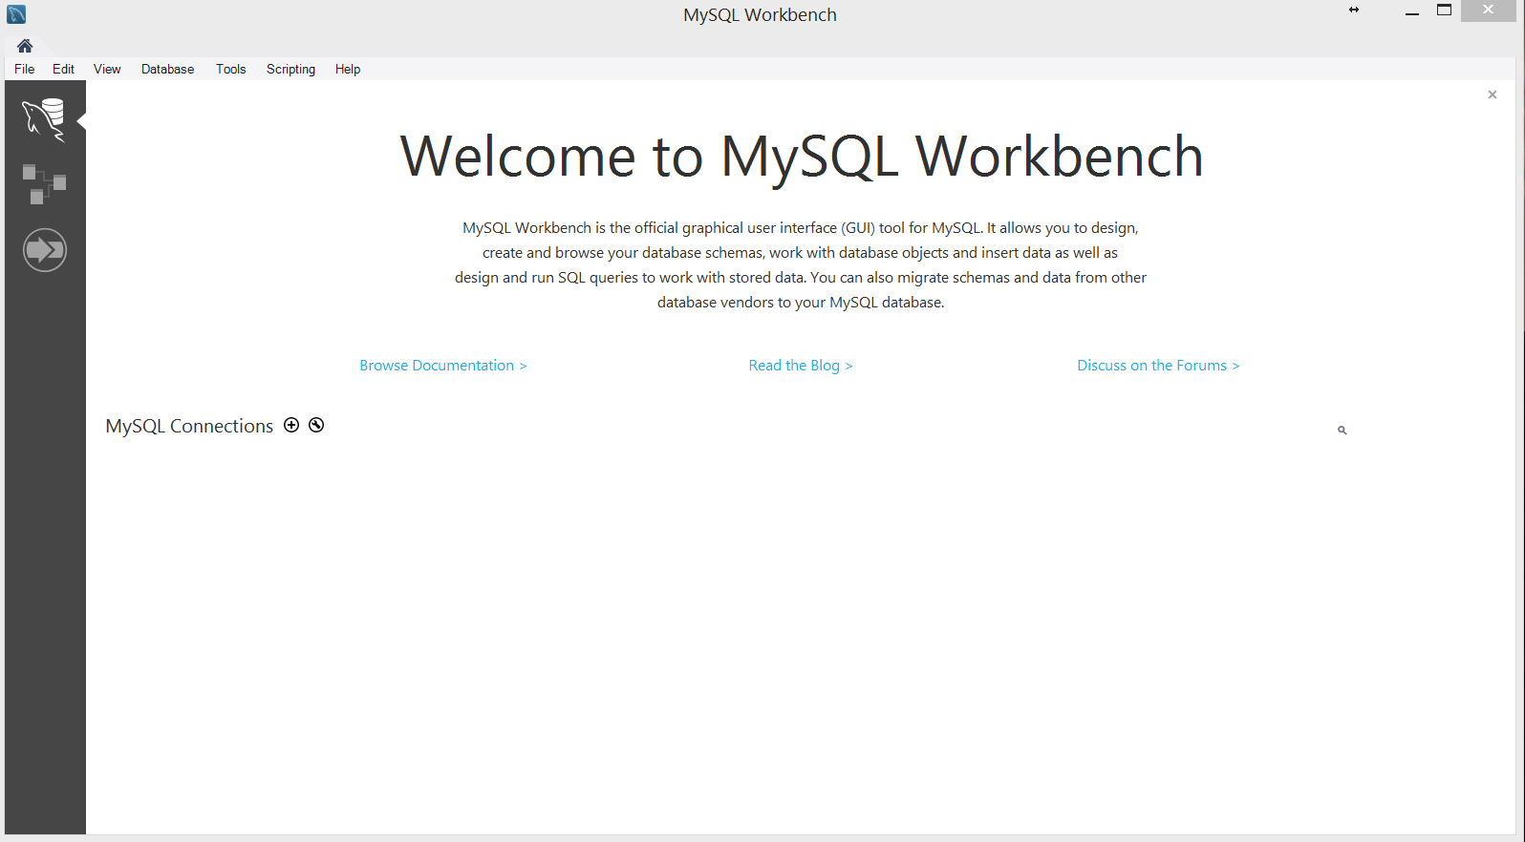
Windows users: go to Part II below
Mac Users:
- Select “MacOS” from the “Select Platform” drop-down menu. Download MySQL Workbench 8.0.21 (listed as “macOS (x86, 64-bit), DMG Archive”). It will be your only choice.

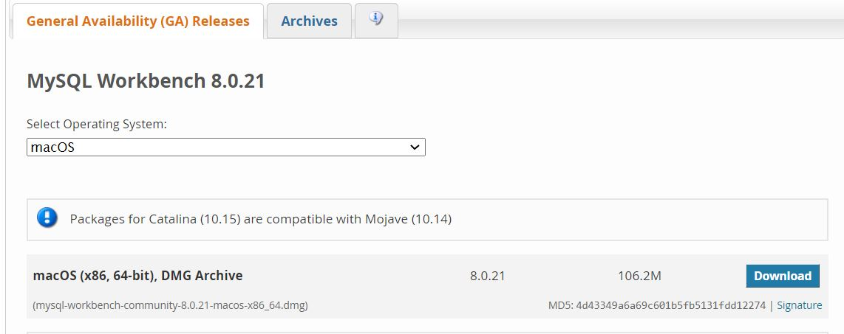

- At the “Begin Your Download” page, it may ask you to login or sign up for a free account. Do not worry about it, just click on “No thanks, just start my download” at the end of the page.

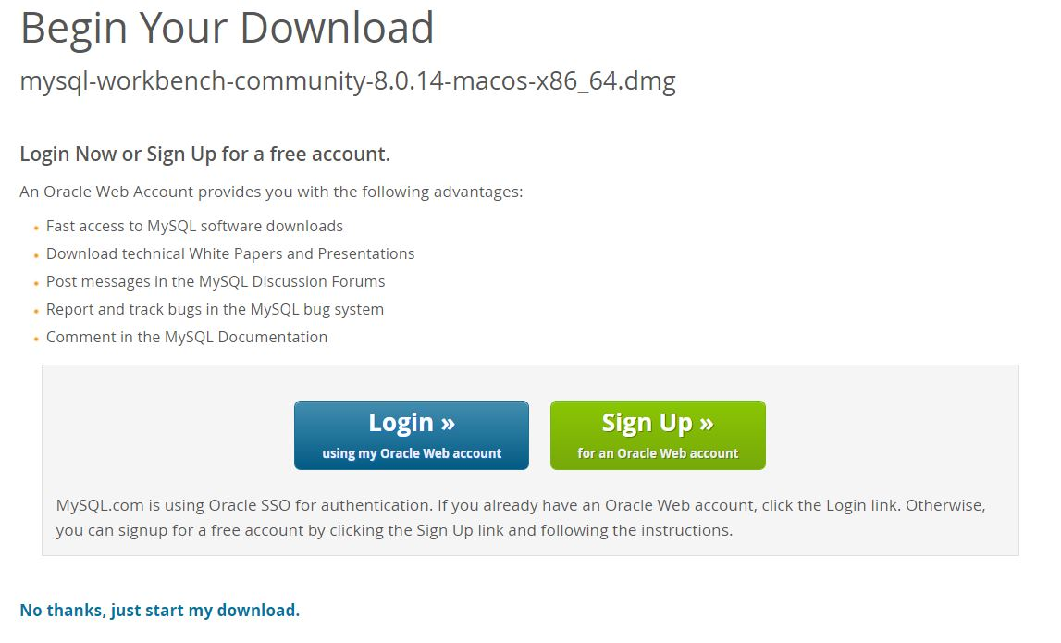

- Install the software just like you would any other program (double-click on the installer and follow the instructions to install the software on your computer).
Part II. Setting up a connection in SQL Workbench (in the lab or your own laptop):
- If you’re working outside of Temple’s campus, you can skip to step 2.
If you’re on a lab computer, make sure you have logged in with your own MIS username. Otherwise, you might accidentally log in to SQL Workbench as someone else. If the computer is already logged in, log out first!
If you are on your own laptop on Temple’s campus, make sure you are connected through the TUSecure wireless network. To get instructions for connecting to TUSecure visit: http://www.temple.edu/cs/wireless/#tusecure
- Start SQL Workbench.
- Click on the “plus sign” next to MySQL Connections to create a new connection.
- At the “Setup New Connection” dialog, fill in the information as follows:
Connection Name: mis2502
Hostname: dataanalytics.temple.edu
Username: Your username given to you by your instructor

- The username and password is available in the gradebook on the community website. The first value that starts with “m” is the username, and the second value is the password.
- For the Connection Name, if it says that “mis2502” is already taken, make the connection name something else. Any name is ok for this.)
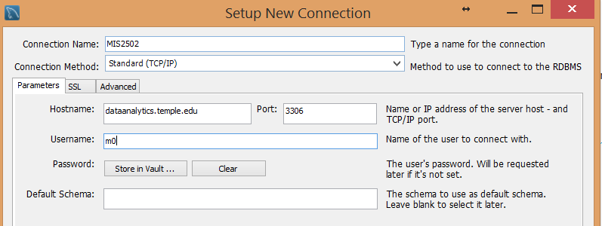
- Click “OK” and you’ll see the connection under “MySQL Connections”:
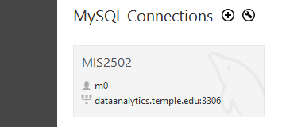
Click on the connection. Make sure the user name matches your username (it should NOT be m0)!
- It will ask you for your password. Enter your password (it’s case sensitive), select “save in the vault” and click OK.
(If you’re in a lab, don’t save your password in the vault or other people will be able to access your account!)
- You’ll see the main window for MySQL Workbench:
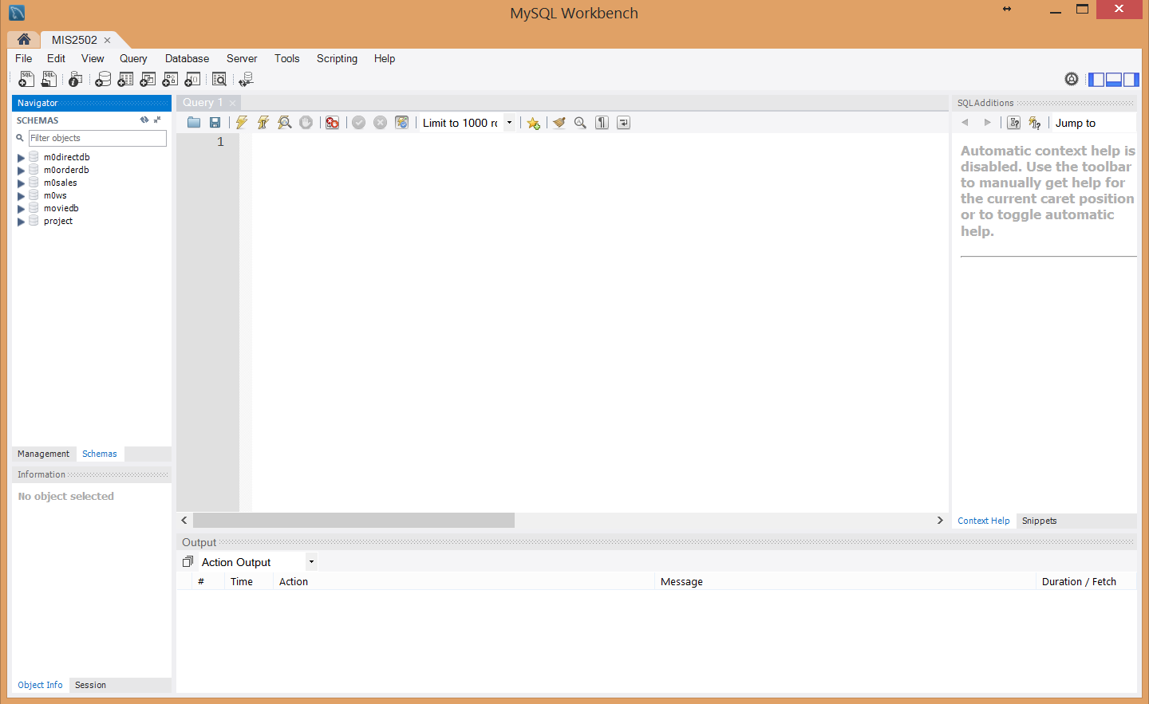
All you really care about is the Query 1 tab on the right and the SCHEMAS section on the left. You may have to click on the Schemas Tab, on the left towards the bottom, next to “Management”

- Try a query. In the SQL File 1 window, type: SELECT * FROM moviedb.actor;
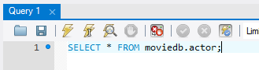
Then click the lightning bolt to execute the query:
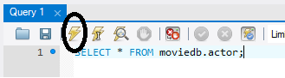

You’ll see output like this:

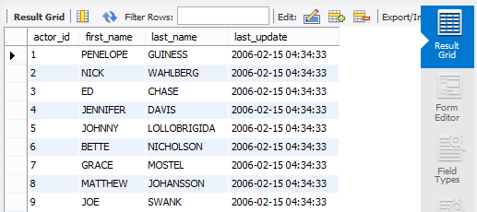

You’ve successfully run your first query!

