Vertabelo Instructions
MIS 2502

How to create an account in Vertabelo?
- Access to vertabelo.com and click “sign up”.
- You have to create an academic account by using your TUemail. Click ‘register here’ and follow the instruction.
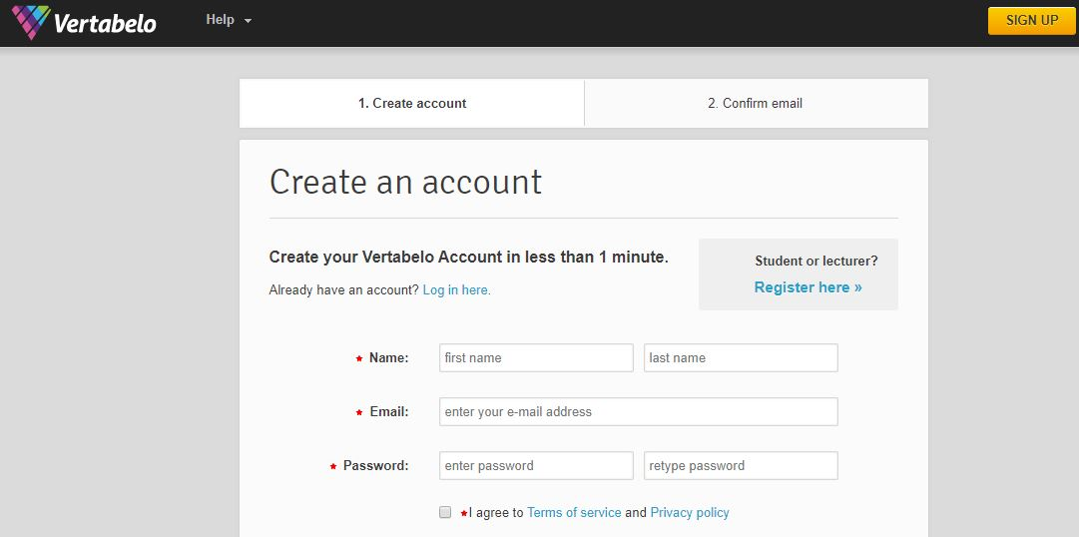

Follow these steps below to help create your database schema using Vertabelo.
Step 1: From your main dashboard, CLICK “Create New Document” in the upper-left corner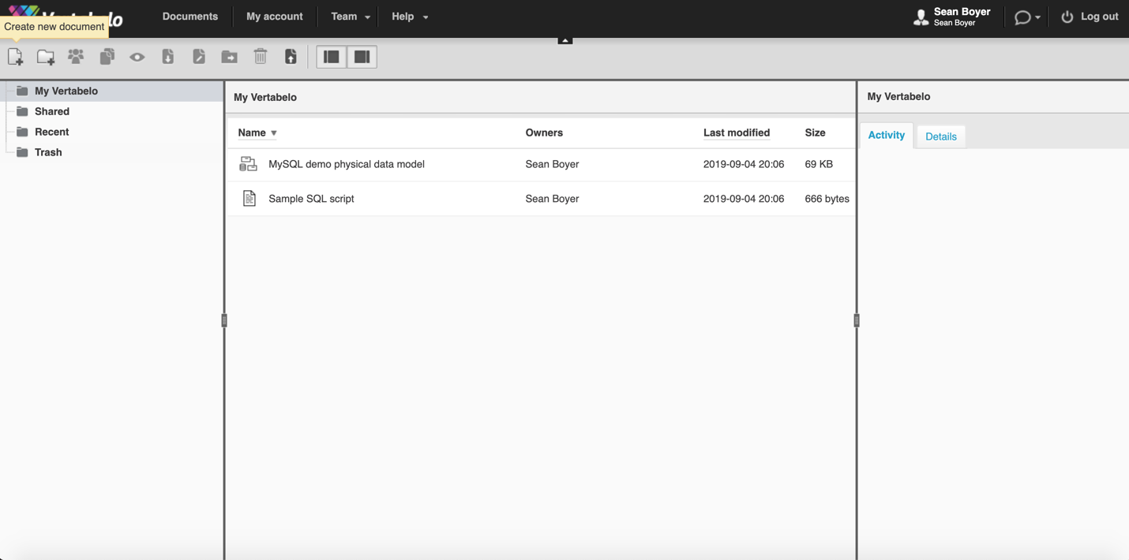

Step 2: Select the Physical Data Model option and CLICK Create.

Step 3: Give your project a name and select any of the Database engine options e.g. MySQL 5.x
Leave the Content radio button value as empty. CLICK start modeling to access your workspace.

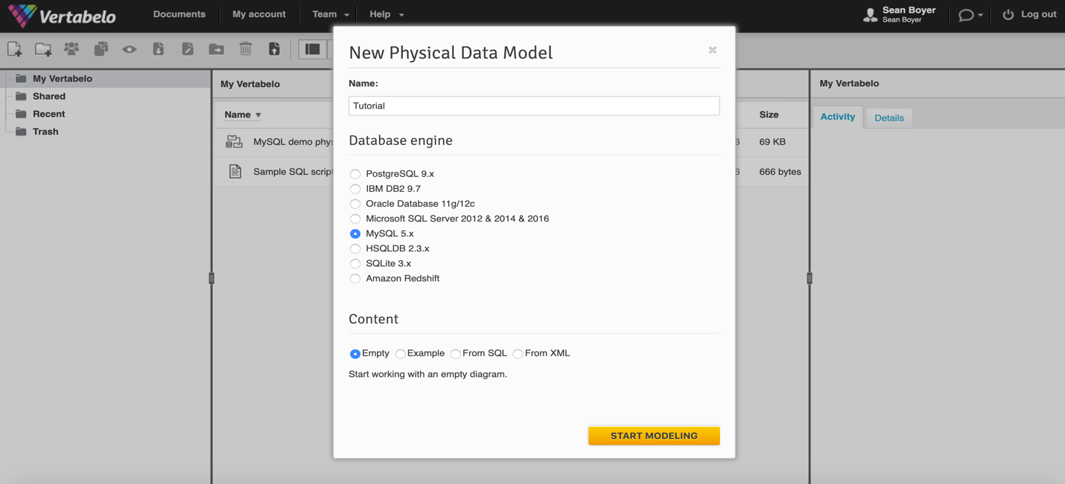
Step 3: SELECT the “Add New Table” Tab and click on your workspace (the white area in the middle of your screen) to create a new entity table.
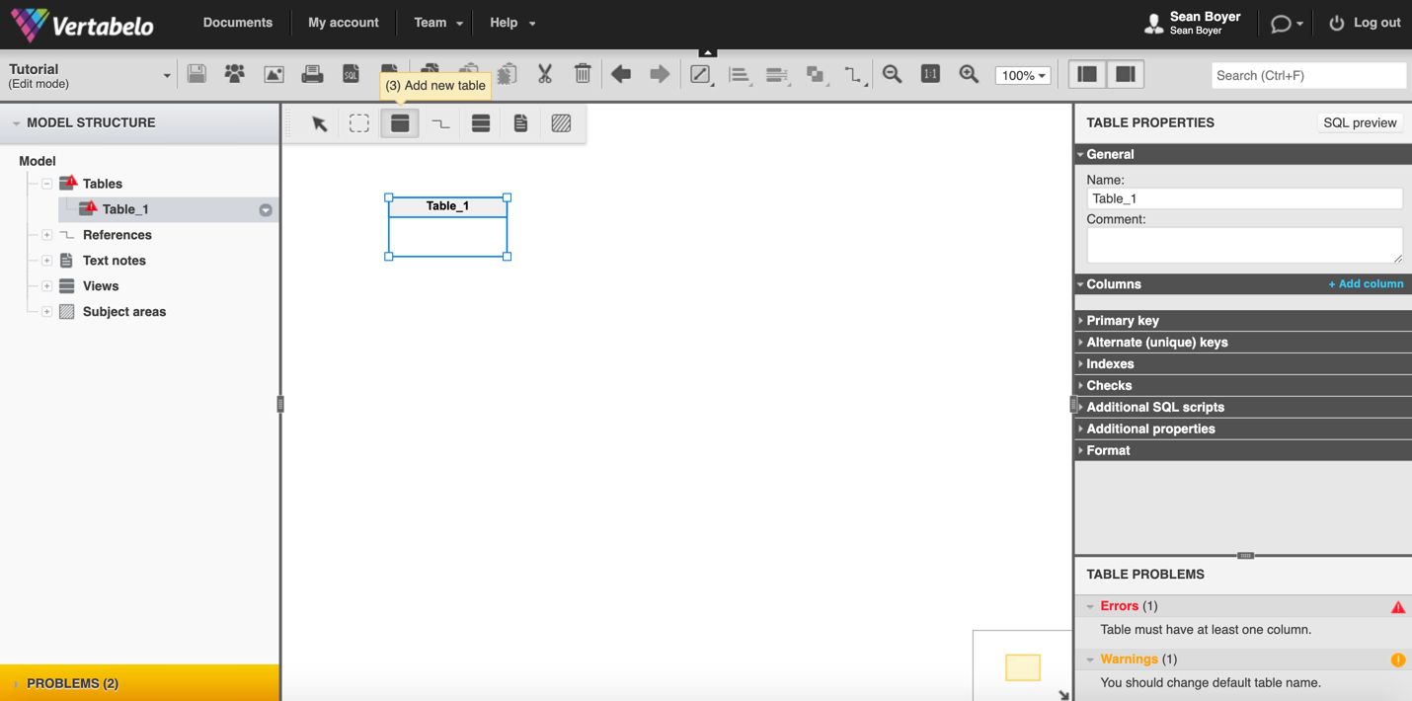

Step 4: Use the TABLE PROPERTIES tool bar on the right to give your table a name. CLICK the “+Add column” button to add attributes to your table.

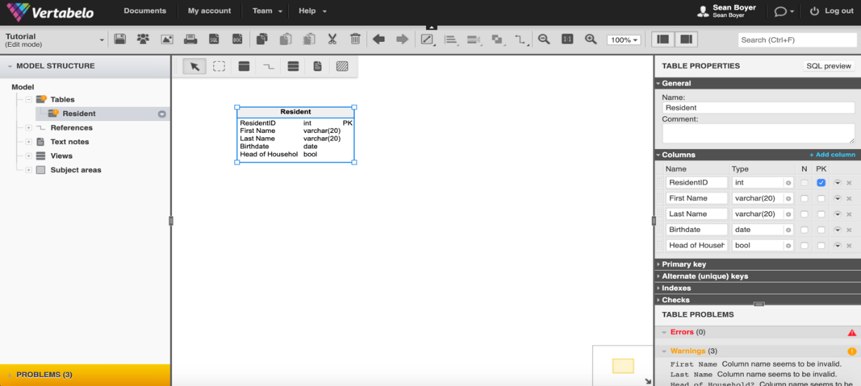
“Columns” Fields Explained:
- Name: Give the attribute an appropriate name.
- Type: Give the attribute an appropriate data type. (This part is optional for the assignment/ICA)
  - Int: Any whole number i.e 1, -1, 12345, 10, -15
  - Varchar(%)*: Contains text i.e. “I love data analytics”, “Bob”
  - *The % symbol indicates the maximum character length. That means if you want all of your first names to have a maximum of 20 letters, replace % with 20.
  - Boolean: Binary outcomes i.e true/false, yes/no
  - Date: Date or time i.e. “9/4/2019”, “11:11 PM”
- N (Nullable): If the box is checked, the attribute may have a value of null (nothing). Ignore this field for now.
- PK (Primary Key): Check this box on the same row as your primary key attribute.
Step 5: Create a relationship between two entities by clicking the relationship tab and dragging your mouse across both entities. A line connecting both entities will appear. Depending on the type of relationship, a foreign key (FK) may appear inside of a table.
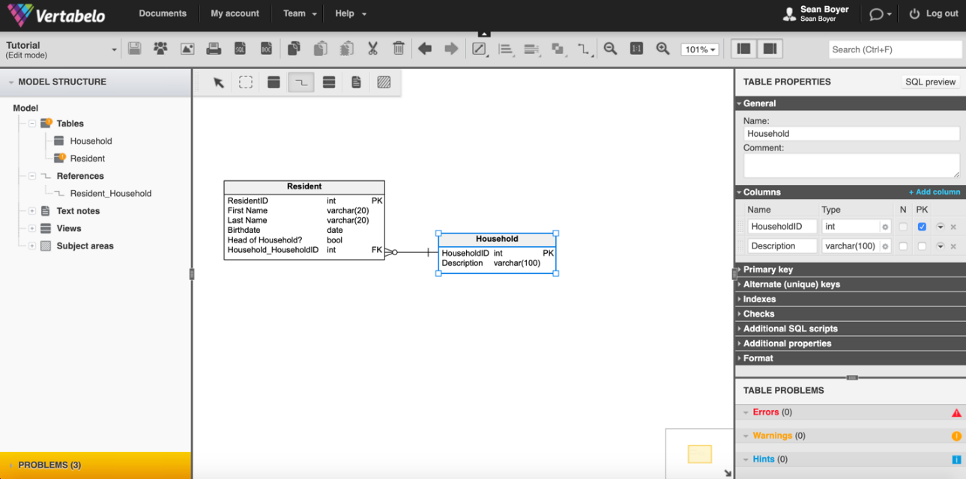
Step 6: (Reference the picture below) Click on the relationship line to modify the relationship. You may need to change it from one-to-many to one-to-one etc. If you have the right type of relationship, but in the wrong order, CLICK the “Swap Reference” button. Use the “Cardinality” tab under the “General” tool bar on the right to edit the type of cardinality.

Symbols:
1..* means one-to-many
1..1 means one-to-one
The others reference minimum cardinality, which is not required for this exercise.

*REMEMBER* many-to-many relationships require the addition of a new entity table.
i.e. If the entities Unit and Household had a many-to-many relationship, you need to make a new entity table called “UnitHousehold” with a one-to-many relationship between Unit & UnitHousehold AND Household & UnitHousehold!! UnitHousehold should contain the primary keys of both Unit AND Household as foreign keys.
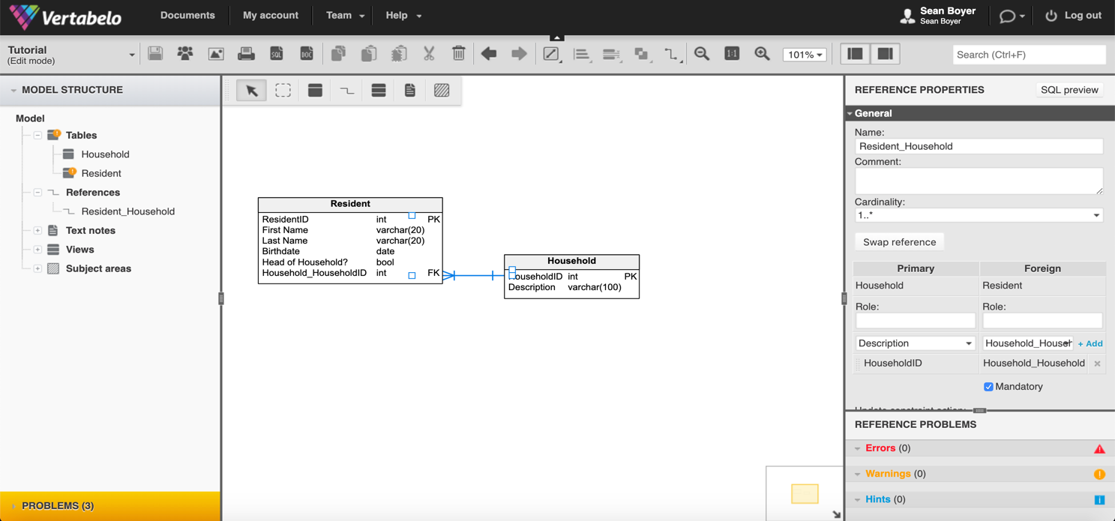

In order to practice proper etiquette, you should have the foreign key (FK) of Resident connected to the primary key (PK) of Household with the relationship line. Vertabelo might not do this for you, but you can easily move the tables to make this happen.

Step 7: Save the tears by MAKING SURE TO SAVE YOUR WORK! CLICK the SAVE ICON to do so.

How to place Schemas created in Vertabelo into Word documents?
- After creating your schema in Vertabelo, export a schema as an image file (with a .png file extension) from Vertabelo. To do so, click Export Model to Image.

Select PNG, then click generate and download the file

