**[Setting up R and RStudio](https://community.mis.temple.edu/mis2502sec004spring2021/2021/03/15/setting-up-r-and-rstudio/)**

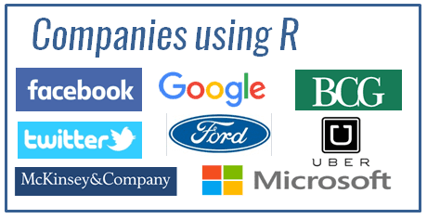

We will be using R and RStudio for the rest of the semester. Please see the link below and install the software before next Monday (3/22).

[**R**](http://www.r-project.org/)is a [widely-used](http://www.listendata.com/2016/12/companies-using-r.html), open-source statistical analysis platform. [**RStudio**](http://www.rstudio.com/) is an integrated development environment for R – that means it makes using R easier!

* ***You should install both software packages – R and RStudio! Don’t just install R or your life will be difficult!***

We’ll be using this software to do some advanced analytics in the second half of the semester! You can get a full copy of the software – PC or Mac – for free!

**First, download and install R:**

* Download the [installation package for R](https://cloud.r-project.org/).
  + Choose the link for your operating system (Windows or MacOS).
    - If you have Windows, choose the “base” installation file.
    - If you have a Mac, you’ll have to choose the one that corresponds to your version of MacOS.
  + Download the latest version (Currently the latest version is the latest version is R 4.0.4. But if there is a newer version, simply download the latest version.)
  + Install the software, accepting the default options.

**Now, download and install RStudio: (You need to have R installed first!)**

* Download the [appropriate installer from the RStudio website](https://www.rstudio.com/products/rstudio/download/).
  + We will use the **RStudio Desktop (Open Source License)**version, which is free.
  + Scroll down to the bottom of the page, and choose the link for your operating system (Windows or MacOS).
  + Download the latest version (Currently the latest version is RStudio 1.4.1106. But if there is a newer version, simply download the latest version.)
  + Install the software, accepting the default options.

After both are installed, you’re always going to run RStudio, which will use R behind the scenes to give you a pleasing analytics experience!