Assignment #2: SQL Part 1 – Basic Queries

Submission Instructions
Due: Thursday, Feb 4, 2022 at 7:59 pm
- Complete and submit the answer sheet on page 3 as a word or PDF document through Canvas>Assignments>To-Do.
- You can copy and paste the (i) SQL query and (ii) the results from SQL Workbench.
- If you do not follow the instructions, your assignment will be counted late.
- Late Assignment policy: All assignments will be assessed a 20% penalty (subtracted from that assignment’s score) for every hour they are late.

Evaluation
Your submission will be graded using two factors:
- A correctly formed SQL query that answers the specific question asked (no extra rows or columns).
- Providing the correct answer to the question (the results returned from MySQL Workbench).

For this assignment, you will be working with the same movie rental database as the ICA #3. The schema is also the same, so you can use the one provided for ICA #3 as a guide.
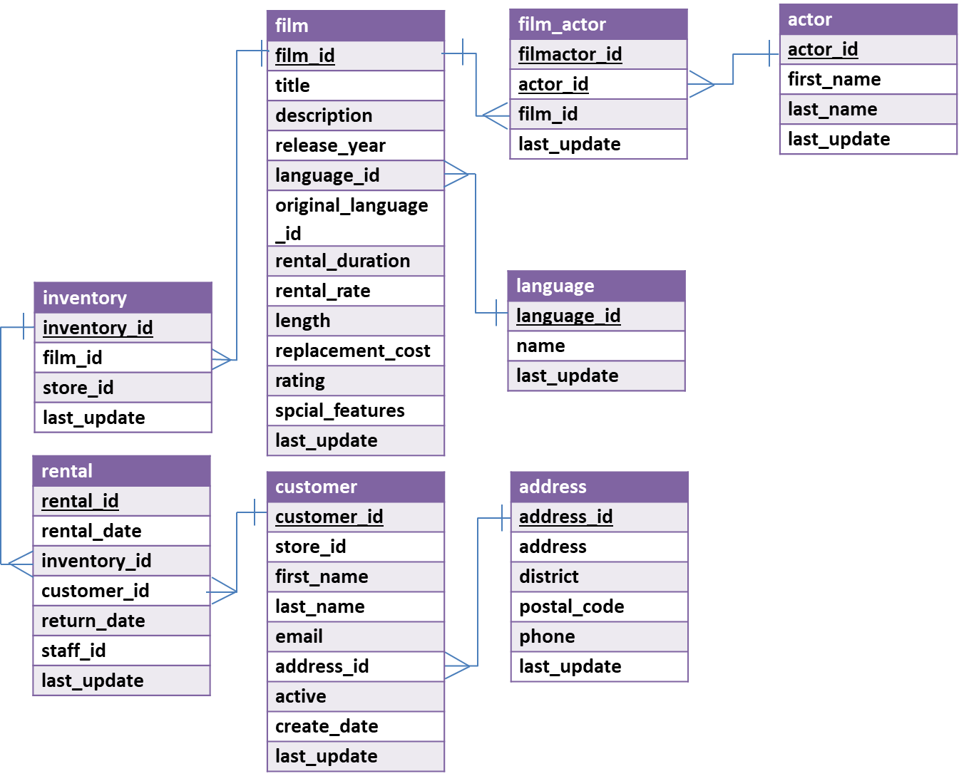
In MySQL Workbench, open the connection to the dataanalytics.temple.edu server using your username and password. Click on the “moviedb” schema and then the tables tab to see the list of tables. Recall the connection configuration as follows:
Connection Name: mis2502
Hostname: dataanalytics.temple.edu
Username: Your username is available on Canvas under Grades>MySQL ID/PW
Questions
- What are the address and phone number for address in district Tennessee and postal code lower than 70000?
Display: address and phone number

- What are the three most popular first name among the actors in the database? (Assume no ties)
Display: first name and the number of times that first name appears

- Display all rental rates of movies (without repetition) in the database.
(Hint: Rental rates are stored in ‘rental_rate’ column in film table)
Display: rental rates

- What is the average length for each rental duration?
Display: rental duration and average length
- How many PG rating movies mention ‘of’ in their description?
Display: number of movies
- How many customers using store 1 have first name “Kelly”?
(Hint: Customer using store 1 has store_id =1)
Display: number of customers

- For different film ratings (i.e., G, PG, R, NC-17), which film rating has the highest average rental rate?
Display: highest rating and its average rental rate

- Return the first five unique first name of customers which starts with a letter “S” based on alphabetical order.
Display: first name

- (Bonus question - optional) In 'address' table, count the number of rows (i.e., address) using (1) asterisk, *, and (2) address2 column. What are the two numbers? If they are different, explain why.

ANSWER SHEET
Assignment #2: SQL Part 1 - Getting Data out of the Database
Question |  | SQL Query | Results/Answer from MySQL Workbench
1 | What are the address and phone number for address in district Tennessee and postal code lower than 70000?
2 | What are the three most popular first name among the actors in the database? (Assume no ties)
3 | Display all rental rates of movies (without repetition) in the database
4 | What is the average length for each rental duration?
5 | How many PG rating movies mention ‘of’ in their description?
6 | How many customers using store 1 have first name “Kelly”?
7 | For different film ratings (i.e., G, PG, R, NC-17), which film rating has the highest average rental rate?
8 | Return the first five unique first name of customers which starts with a letter “S” based on alphabetical order.
9 | (Bonus question - optional) In 'address' table, count the number of rows (i.e., address) using (1) asterisk, *, and (2) address2 column. What are the two numbers? If they are different, explain why.

