Assignment #4: NoSQL Part 1
Submission Instructions
Due: Tuesday, 03/07/2022 at 7:59 pm
- Submit your solutions as a Word or PDF file through Canvas>Assignments>To-Do.
- If you do not follow the instructions, your assignment will be counted late.
- Late Assignment policy: All assignments will be assessed a 20% penalty (subtracted from that assignment’s score) for every hour they are late.

Evaluation
- Your submission will be graded based on two factors:
- A correctly formed NoSQL query that answers the specific question asked (no extra rows or columns).
- Providing the correct answer to the question (the results returned from MongoDB Compass).

Here is an example of what a document in this collection looks like (JSON Pretty Print):
Restaurantdb.restaurant

{
"_id": {
"$oid": "5eb3d668b31de5d588f4292d"
},
"address": {
"building": "469",
"coord": [-73.961704, 40.662942],
"street": "Flatbush Avenue",
"zipcode": "11225"
},
"borough": "Brooklyn",
"cuisine": "Hamburgers",
"employee": 4,
"year": 1820,
"option": ["Delivery", "Drive-through", "Takeout", "Dine-in"]
}

Here is how to view the MongoDB code for an aggregation pipeline:
- Connect to the server on MongoDB Compass.
- Open the database and collection and click on the aggregations tab.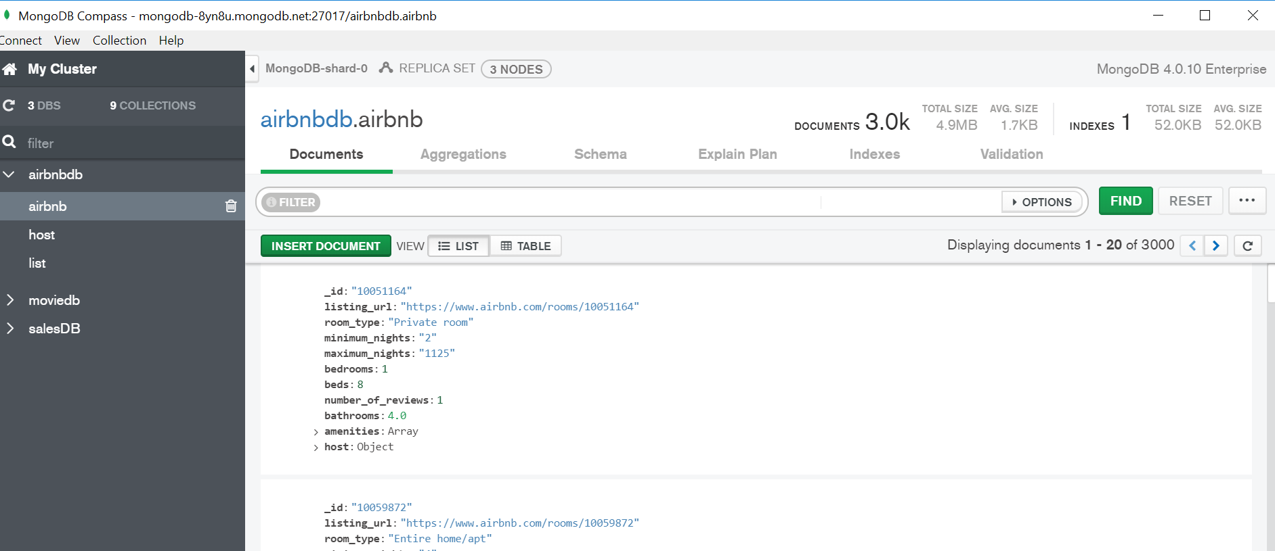
- After creating your pipeline by adding stages, click “Export Pipeline to Language”.
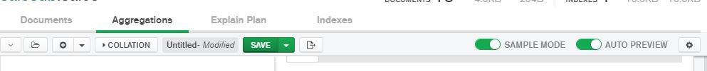

- The text shown in the left box is the MongoDB code for the last pipeline you created.
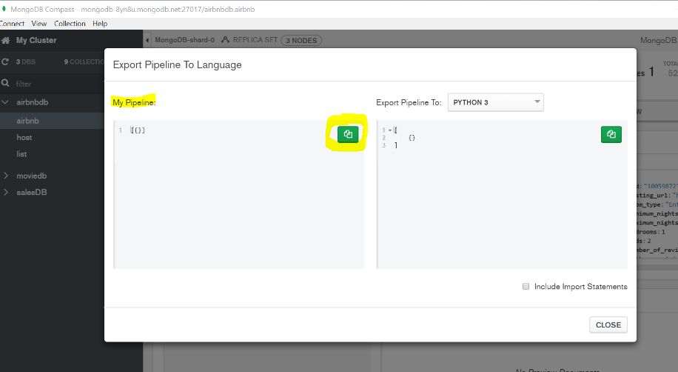
Instructions:
Use MongoDB Compass and open restaurant collection in the RestaurantDB database to answer the questions below. Include the query used (make sure to include all stages) and the results of the query.
Question | Query Used | Answer
- How many American restaurants are opened in 2009?
- Return the number of employees and the opening year of chicken restaurants.
- Return the borough, cuisine, and the opening year of two oldest restaurants.
- What is the total number of employees of restaurants in each borough? Only return the borough and the total number of employees of the largest total number.
- Return the highest number of employees among the restaurants that were opened in 2003. (Note: Do not use $sort for this question. no point will be given if you use $sort.)
- Return the cuisine, employee, and opening year of the most recently opened “Irish” restaurant that has less than 7 employees.
- (Optional) Return borough and opening year of restaurants which either (a) opened in 1820 or (b) are in Manhattan and opened after 2003 (including 2003). |  | (show the first three results)

- What is the equivalent SQL code for the query you found in question 2?

- What is the equivalent SQL code for the query you found in question 6?

