In-Class Activity #6: NoSQL Part 1

Submission Instructions
Submit your solutions as a Word or PDF file through Canvas>Assignments>To-Do Submissions.
Instructions:
Open the list collection under the AirbnbDB and answer the questions below. Include the query used and the results of the query if specified. Recall that MongoDB Compass is case sensitive.
Here is an example of what a document in this collection looks like (JSON Pretty Print):
Airbnbdb.airbnb

{
"_id": "25167125",
"listing_url": "https://www.airbnb.com/rooms/25167125",
"room_type": "Private room",
"minimum_nights": "1",
"maximum_nights": "1125",
"bedrooms": 1,
"beds": 1,
"number_of_reviews": 11,
"bathrooms": {
"$numberDecimal": "1.0"
},
"amenities": [
"Wifi",
"Air conditioning",
"Kitchen",
"Free parking on premises",
"Pets allowed",
"Breakfast",
"Free street parking",
"Heating",
"Smoke detector",
"First aid kit",
"Essentials",
"Shampoo",
"Hangers",
"Laptop friendly workspace",
"Private entrance",
"Bed linens",
"Extra pillows and blankets",
"Luggage dropoff allowed",
"Cleaning before checkout",
"Disabled parking spot",
"Accessible-height bed",
"Host greets you"
],
"host": {
"host_id": "11490944" }
}
Here is how to view the MongoDB code for an aggregation pipeline:
- Connect to the server on MongoDB Compass.
- Open the database and collection and click on the aggregations tab.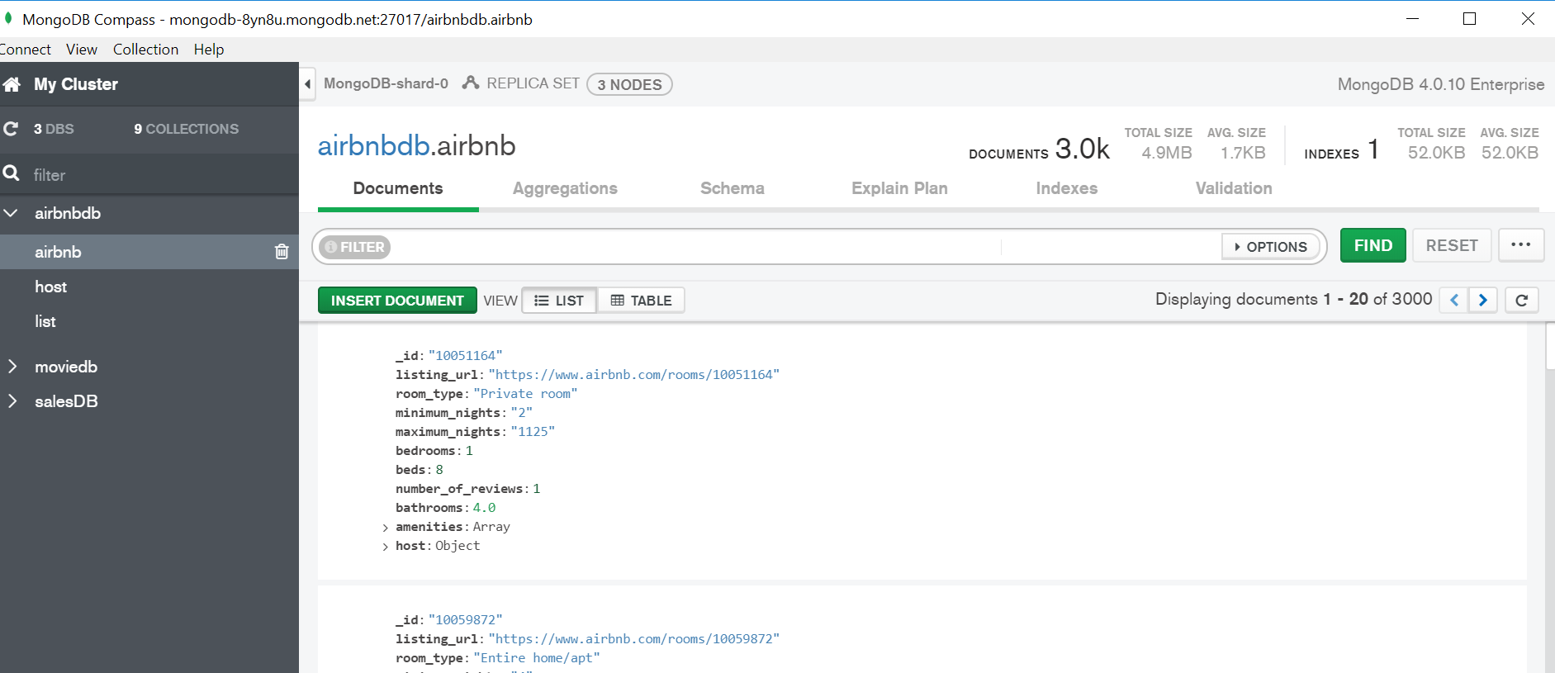

- After creating your pipeline by adding stages, click “Export Pipeline to Language”.
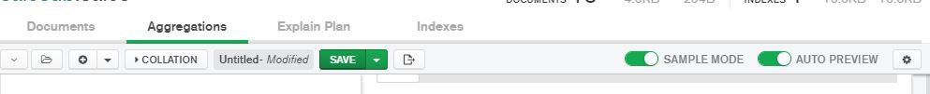

- The text shown in the left box is the MongoDB code for the last pipeline you created.
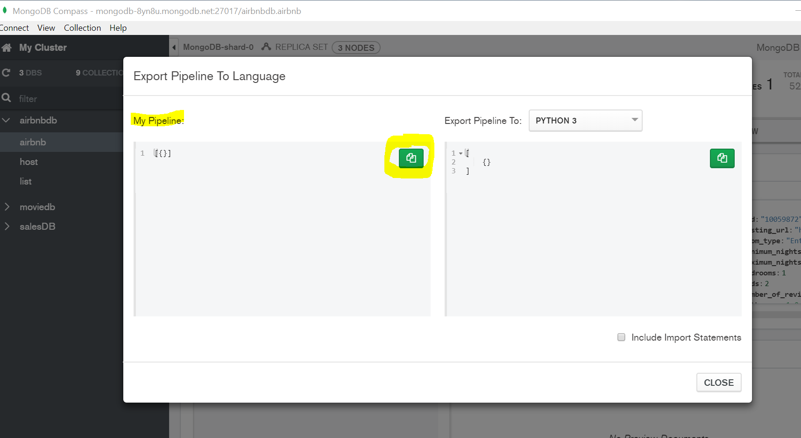

- What is the query to display the _id, bedrooms, and number of reviews of all the airbnbs?
Query:

- What is the maximum number of beds in all listings?
Query:

Query Result:

- What is the equivalent SQL syntax for the query in question 2?
SQL Syntax:

- How many housings have 2 beds?
Query:

Query Result:

- Display _id of housings that have a room type of Private room or have exactly 2 bathrooms.
Query:

Query Result: (show the first three results)

- What is the total number of bedrooms by each room type among housings that have more than 2 beds?

Query:

Query Result:

- A customer is looking for a listing that has at least 1 review, at least 1 bed, and has a number of maximum nights of exactly 30. Display the id and number of beds of the highest id. (Hint: pay attention to numbers that are recorded as strings in the database).

Query:

Query Result:

- What is the equivalent SQL syntax for the query in question 7?

