Assignment #2: SQL Part 1 – Basic Queries

Submission Instructions
Due: Wednesday, 2/15/2023 at 11:59 pm
- Complete and submit the answer sheet on pages 3 and 4 as a word or PDF document through Canvas>Assignments>To-Do.
- You should copy and paste the (i) SQL query and (ii) the results from MySQL Workbench.
- Do not compose your work in MS Word and copy/paste it into MySQL Workbench. This approach will only frustrate you. Instead, compose your queries in MySQL Workbench and paste them into MS Word.
- If you do not follow the instructions, your assignment will be counted late.
- Late Assignment policy: All assignments will be assessed a 20% penalty (subtracted from that assignment’s score) for every hour they are late.

Evaluation
Your submission will be graded using two factors:
- A correctly formed SQL query that answers the specific question asked (no extra rows or columns).
- Providing the correct answer to the question (the results returned from MySQL Workbench).

For this assignment, you will be working with the same movie rental database as the ICA #3. The schema is also the same, so you can use the one provided for ICA #3 as a guide.
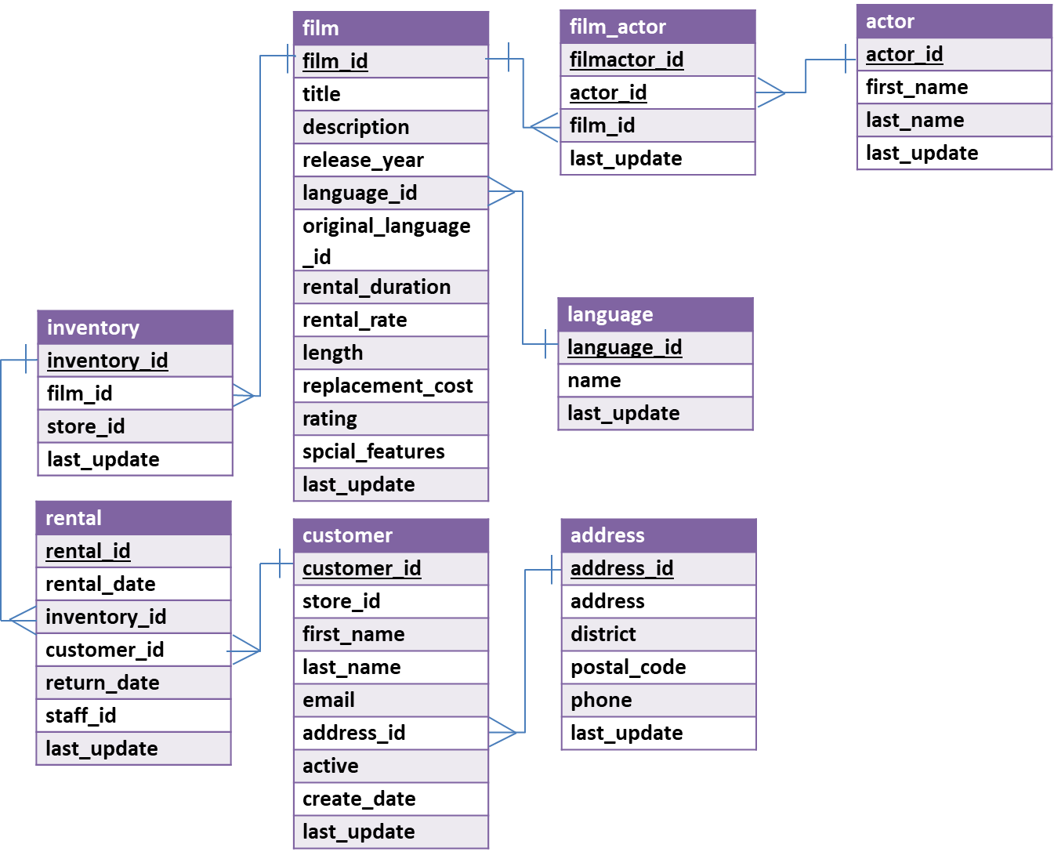
In MySQL Workbench, open the connection to the dataanalytics.temple.edu server using your username and password. Click on the “moviedb” schema and then the tables tab to see the list of tables. Recall the connection configuration as follows:
Connection Name: mis2502
Hostname: dataanalytics.temple.edu
Username: Your username is available on the MIS Community Gradebook
Questions
- What are the street addresses and phone numbers for California addresses where the postal code has a numeric value lower than 20000?
Display: address and phone number

- What are the three most popular first name among the actors in the database? (Assume no ties)
Display: first name and the number of times that first name appears

- Display all rental rates of movies (without repetition) in the database.
(Hint: Rental rates are stored in ‘rental_rate’ column in film table)
Display: rental rates

- You want to find out if movies in different languages command higher rental rate than others. Determine the average rental rate for movies, organized by their language_id.
Sort your output so that language_id values are shown in a nice predictable order from lowest to highest.
Display: language id and the average rental rate
- How many PG rating movies mention ‘of’ in their description?
Display: number of movies
- How many customers using store 1 have first name “Kelly”?
(Hint: Customer using store 1 has store_id =1)
Display: number of customers

- For different film ratings (i.e., G, PG, R, NC-17), which film rating has the highest average rental rate?
Display: highest rating and its average rental rate

- Return the first five unique first name of customers which starts with a letter “S” based on alphabetical order.
Display: first name

ANSWER SHEET
Assignment #2: SQL Part 1 - Getting Data out of the Database
Question |  | SQL Query | Results/Answer from MySQL Workbench
1 | What are the street addresses and phone numbers for California addresses where the postal code has a numeric value lower than 20000?
2 | What are the three most popular first name among the actors in the database? (Assume no ties)
3 | Display all rental rates of movies (without repetition) in the database
4 | You want to find out if movies in different languages command higher rental rate than others. Determine the average rental rate for movies, organized by their language_id.  Sort your output so that language_id values are shown in a nice predictable order from lowest to highest.
5 | How many PG rating movies mention ‘of’ in their description?
6 | How many customers using store 1 have first name “Kelly”?
7 | For different film ratings (i.e., G, PG, R, NC-17), which film rating has the highest average rental rate?
8 | Return the first five unique first name of customers which starts with a letter “S” based on alphabetical order.

