Assignment #3: SQL Part 2 – Advanced Queries

Submission Instructions
Due: Wednesday, 2/22/2023, 11:59 pm
- Complete and submit the answer sheet as a word or PDF document through Canvas>Assignments>To-Do. (The answer sheet is a separate document.)
- You can copy and paste the (i) SQL query and (ii) the results from SQL Workbench.
- Late Assignment policy: All assignments will be assessed a 20% penalty (subtracted from that assignment’s score) for every hour they are late.
Evaluation
Your submission will be graded using two factors:
- A correctly formed SQL query that answers the specific question asked (no extra rows or columns).
- Providing the correct answer to the question (the results returned from MySQL Workbench).

For this assignment, you will be working with the same movie rental database as ICA #4. The schema is also the same, so you can use the one provided for ICA #4 as a guide.

Recall that an "Advanced" SQL query requires the use of one or more JOINs, a subselect, or both.
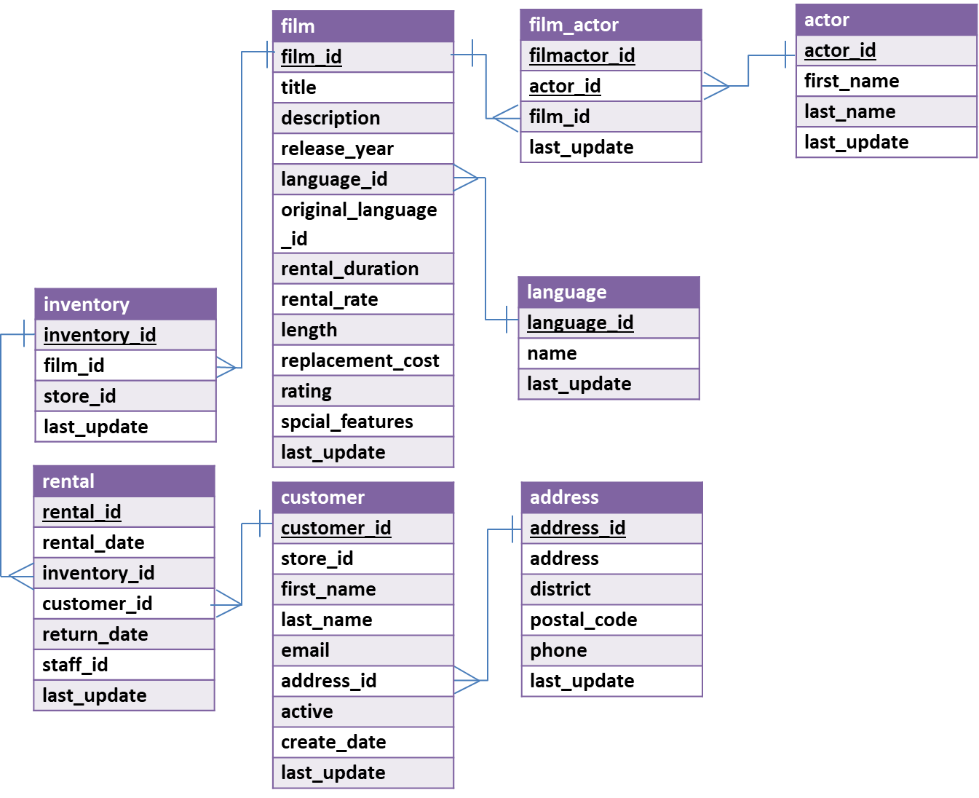
Questions
- How many times has each language been used in films? Return the value for all six languages.
Display: language name and the number of films

- How many actors stared in the film titled “BREAKING HOME”?
Display: number of actors

- Who has rented movies in Japanese language? Return only the first five distinct results in alphabetical order by last name.
(Hints: In the language table, there is a field “name” that contains the film language names.)
Display: first name and last name

- How many different districts exist in the address table?
Display: number of unique distinct names of districts

- What actor has appeared in the most movies? How many movies did s/he appear in?
(Hint: Assume no ties - there’s only one actor who appears in the most movies.)
Display: first name, last name and number of movies

- What store ids are in the Georgia district and how many rentals are recorded for each one?
Display the district, store_id, and the number of rentals

- What is (are) the PG-rated movie(s) with the largest replacement cost at store 2? And how much is it (are they)?
(Hint #1. PG-rated movies have rating value equal to ‘PG’;
Hint #2. Use store_id in the Inventory table;
Hint #3. There may be more than one movie returned.)
Display: movie title and replacement cost

- What is (are) the title(s) and the rental rate of the movie(s) that has (have) the least expensive rental rate among movies acted by Emily Dee?
(Hint: There can be more than one movie)
Display: movie title, rating, and rental rate

- (Bonus question-optional) What is the average of the average rental rate for each movie rating?
(Hint: Find out the average rental rate of each rating and then compute the average of those numbers … an average of averages.)
Display: Just one number – the average of the average rental rate per rating.
(The bonus points will be added to your final grade of this assignment. There will be no partial credit for this question.)

