Assignment #5: NoSQL Part 2
Submission Instructions
Due: Wednesday 3/29 at 11:59 pm
- Submit your solutions as a Word or PDF file through Canvas>Assignments>To-Do.
- If you do not follow the instructions, your assignment will be counted late.
- Late Assignment policy: All assignments will be assessed a 20% penalty (subtracted from that assignment’s score) for every hour they are late.

Evaluation
- Your submission will be graded using two factors:
- A correctly formed NoSQL query that answers the specific question asked (no extra rows or columns).
- Providing the correct answer to the question (the results returned from MongoDB Compass).

Here is an example of what a document in this collection looks like (JSON Pretty Print):
Restaurantdb.Restaurant

{
"_id": {
"$oid": "5eb3d668b31de5d588f4292d"
},
"address": {
"building": "469",
"coord": [-73.961704, 40.662942],
"street": "Flatbush Avenue",
"zipcode": "11225"
},
"borough": "Brooklyn",
"cuisine": "Hamburgers",
"employee": 4,
"year": 1820,
"option": ["Delivery", "Drive-through", "Takeout", "Dine-in"]
}

Here is how to view the MongoDB code for an aggregation pipeline:
- Connect to the server on MongoDB Compass.
- Open the database and collection and click on the aggregations tab.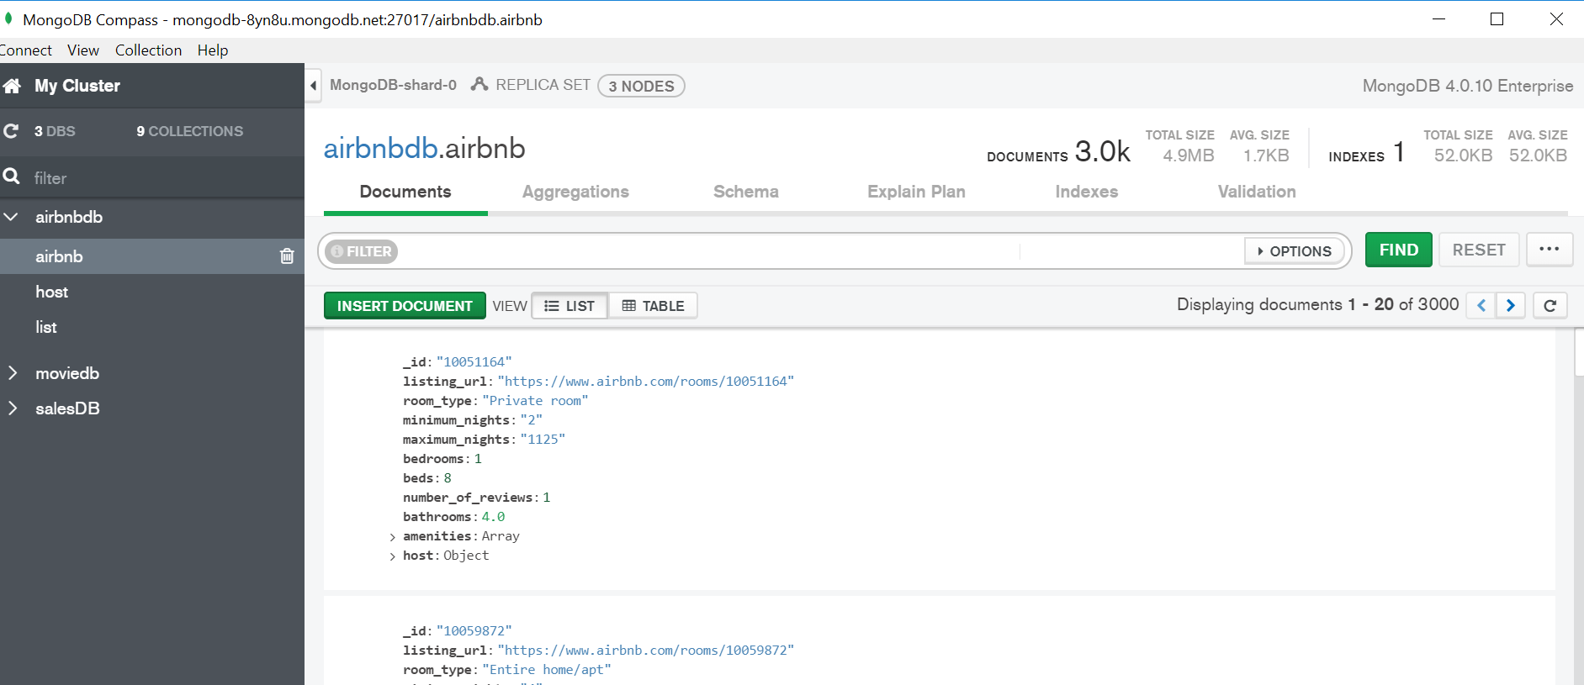
- After creating your pipeline by adding stages, click “Export Pipeline to Language”.
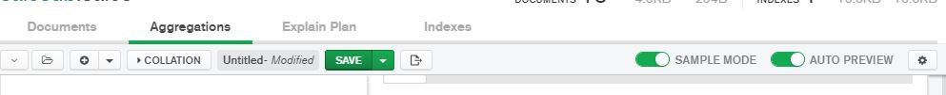

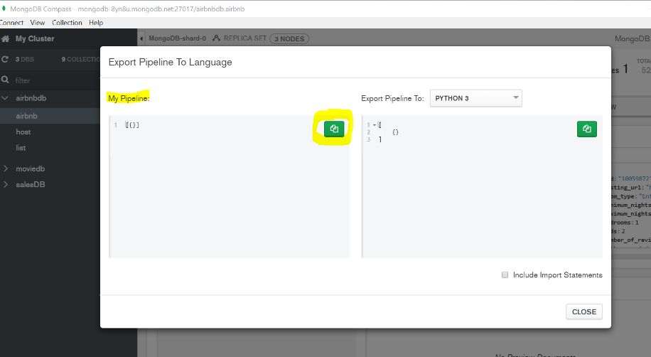
- The text shown in the left box is the MongoDB code for the last pipeline you created.

Instructions:
For questions 1-8, use MongoDB Compass and open the restaurant collection in restaurantDB to answer the questions below. The restaurant collection has 446 documents in it.
Include the query used (make sure to include all stages) and the results of the query.
Question | Query Used | Answer
- What are the borough and the coordinates of the restaurant with the most employees in the database? Return the borough name and the coordinates of the restaurant.
- Among the restaurants that offer 4 dining options and are located in "Bronx", compute the number of restaurants that opened in each year. Show the number of restaurants and year.
- What are the streets and cuisines of the two oldest restaurants in "Brooklyn"? Show the street names and cuisines of the restaurants.
- Among the restaurants that offer only the "Takeout" option and opened in 2010, show the average number of employees by borough. Present all the results based on the lowest to highest average number of employees. |  | (Round query result to second decimal)
- Among the restaurants that offer "Takeout" and "Dine-in" options, what are the three most popular cuisines? Please present the cuisines and the number of restaurants of each cuisine.
- How many restaurants have more than 5 employees and are located in zip code "11361"?
- How many restaurants offer "Hamburgers" and opened in 2010 or later?
- Among the restaurants located at "18 Avenue", return the 2 restaurants with the smallest number of employees. Return the street name, the number of employees, and cuisine of the restaurants
- Open the restaurantdb.list collection. Provide the query that connects the address collection to the list collection and name the field "restaurant_address" to join the tables.

Here is an example of what a document in list and address collection looks like (JSON Pretty Print):
Restaurantdb.list

{
"_id": {
"$oid": "5eb3d668b31de5d588f4292d"
},
"address_id": "2142021",
"borough": "Brooklyn",
"cuisine": "Hamburgers",
"employee": 4,
"year": 1820,
"option": ["Delivery", "Drive-through", "Takeout", "Dine-in"]
}

Restaurantdb.address

{
"_id": "2142021",
"building": "469",
"coord": [-73.961704, 40.662942],
"street": "Flatbush Avenue",
"zipcode": "11225"
}

