# Project 1 –Setups, Date and Time Application

PUT YOUR NAME HERE

|  |
| --- |
| NoName McHiggens |

## Expectations

* Instructor Guidance – High
* Independent Effort – Moderate
* Originality – Low
* Teamwork – *None*

## Description

To build a web application, you need to “cook” with many “ingredients”. You need client-side code, web service code, and (usually) a database.

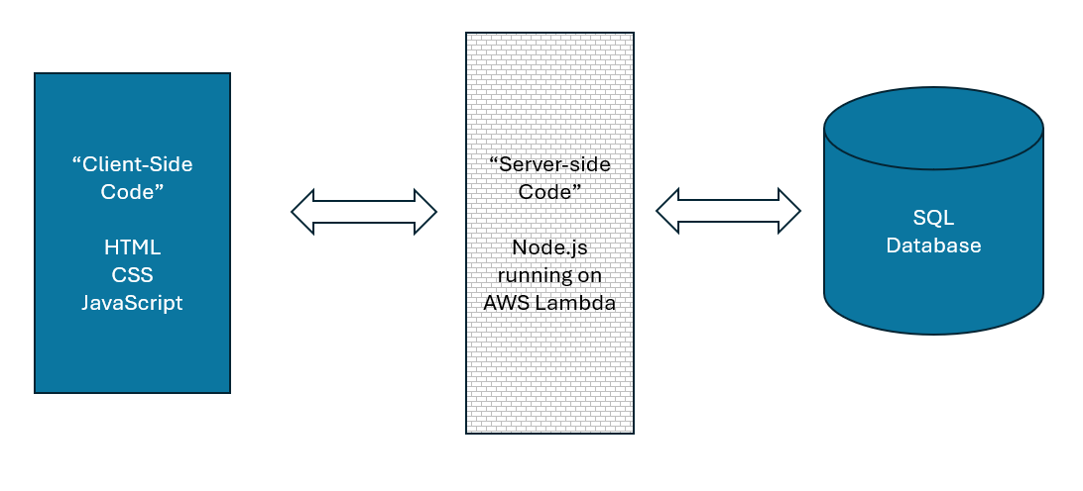

This project (Project 1) steps students through the process of creating a very simple web application that has all those “ingredients”. The final product will be a page that displays the current date and time in Philadelphia. We are using ***a lot*** more technology than is necessary to do this. (This is what’s known as an “over architected” solution.)

However, the process of doing so will help students envision the purpose of each “ingredient” and will also ensure that each student has done all the setup work necessary for future projects in the class.

This project (Project 1) is not a team project. Students are required to do this project as individuals.

## Instructions

1. Did you notice the “PUT YOUR NAME HERE” box at the very beginning of this document? If you haven’t already done so, replace “NoName McHiggens” with your name.
2. Delete your old AWS account from last semester. There is no reason to keep your old AWS account (from the Cloud Architecture course) for the sake of this class (Web Service Programming). ***I want students to delete their old free tier account and make a new one.***

If you have some reason for keeping your old AWS account active (like, you have personal work out there, or you need it for some certification you are studying for) then let your instructor know. You can send me mail at [jeremy@temple.edu](mailto:jeremy@temple.edu).

See this video: (Deleting your old account) <https://youtu.be/TG8wS6D6bJs> (~ 4 mins)

1. Make sure Visual Studio Code is installed, and that you know where your local workspace folder is.

See this video: (VS Code and your local workspace) <https://youtu.be/PJzX5QMrNuQ> (~ 8 mins)

**<< COPY / PASTE YOUR SCREEN SHOT HERE >>**

1. Make a new AWS (free tier) account for this semester. Set up a public S3 bucket and validate that it works.

See this video: (Your new AWS account) <https://youtu.be/TfGbGD8hBio> (~ 15 minutes)

Put the URL to your “Hello Word” page here:

|  |
| --- |
|  |

CONTINUED

1. Using your new AWS account, create two sets of AWS Access keys.

The first access key will be yours for your personal, individual use.

The second access key be shared with other students, later in the semester, for group work.

See this video: (Make a new account) <https://youtu.be/DdHDETdHnJo> (~ 5 minutes)

YOUR ***PERSONAL*** AWS Access Key:

|  |
| --- |
|  |

YOUR ***PERSONAL*** AWS Secret Access Key:

|  |
| --- |
|  |

YOUR ***GROUP*** AWS Access Key:

|  |
| --- |
|  |

YOUR ***GROUP*** AWS Secret Access Key:

|  |
| --- |
|  |

1. Install MySQL Workbench if necessary. (If you still have it from a prior semester, that’s fine.) Set up MySQL Workbench to point to the database server used by the class. Your instructor will provide the credentials you need.

Create your “blue” database using this command: CREATE DATABASE jXXXblue

See this video: (Setting up MySQL Workbench) <https://youtu.be/rMQ7VDZT1e4> (~ 11 minutes)

**<< COPY / PASTE YOUR SCREEN SHOT HERE >>**

1. Set up your project1 folder on S3.

See this video: (Upload and edit the client-side code for project 1) <https://youtu.be/M1alzmkz8Gc> (~20 minutes)

Put your client-side code URL here:

|  |
| --- |
|  |

***REMEMBER*** – Control-Shift-R is better than a regular browser refresh. (Or Command-Shift-R on a MacBook)

1. Set up your project1 function on lambda.

See these videos:

1. Getting ready <https://youtu.be/11bPGuvOWqM> (~10 mins)
2. DO NOT SKIP – SUPER IMPORTANT - Strategy <https://youtu.be/F-CCy8kw7LE> (~8 mins)
3. Setting up your lambda project <https://youtu.be/vc2vnXgo9RM> (~25 mins)
4. Edit your lambda code with VS Code <https://youtu.be/Vqt_sZMNz5k> (~18 mins)

Put your web service endpoint URL here:

|  |
| --- |
|  |

1. Put it all together and validate that everything works.

See this video: (Check your work)

<https://youtu.be/ttlzU3xka7E> (~ 10 minutes)

**<< COPY / PASTE YOUR SCREEN SHOT HERE >>**

## Turn in your work!

When you are done, upload this document to the corresponding “Project 1” assignment out on canvas.

CONTINUED …

## How will this project be graded?

|  |  |
| --- | --- |
| Item | Points |
| Your name / Step 1 | 5 |
| Screenshot / Step 3 | 10 |
| URL / Step 4 | 10 |
| Access keys / Step 5 | 40 |
| Screenshot / Step 6 | 10 |
| URL / Step 7 | 10 |
| URL / Step 8 | 10 |
| Screenshot / Step 9 | 5 |
| **TOTAL** | 100 |

Please see the syllabus for the late policy.