The QR codes on the following pages were generated using the GOQR API found here:
QR codes generated here:
https://goqr.me/
These codes are small enough to be printed on a product label. Regular laptop Web Cameras will have a hard time reading them, but a smart-phone camera should be able to do so.
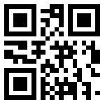
SHAFER

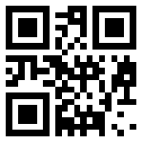
XY1234

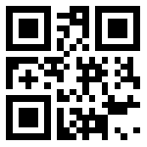
QZ9883

