# Project 2 Part 3 – Fostering Hope Inventory: Check Out (Big Ticket Items)

PUT YOUR NAME HERE

|  |
| --- |
| NoName Mchiggens |

PUT GROUP NUMBER HERE

|  |
| --- |
| X99 |

PUT THE NAMES OF YOUR BUDDIES HERE

|  |
| --- |
| Samuel D. Test, Ima Nuther, Buddy Finkerbean |

## Expectations

* Instructor Guidance – High
* Independent Effort – Moderate
* Originality – Low
* Teamwork – High

## Description

Fostering Hope is a charity with 10 branches in Pennsylvania. The charity serves families and children who are interacting of the Foster-care system in Pennsylvania. Fostering Hope offers three primary services: “Dignity Duffles” (duffle bags for children entering foster care), “Bags of Hope” (care packages filled with emergency supplies to help foster parents get through the first 48 hours of a placement) and “Foster-share closets”.

This project is focused on the “Foster-share closet” service offered by the Northeast Philadelphia Chapter of Fostering Hope. Your goal is to create a system used to track various “big ticket” items in the closet.

This project (Project 2) is a team project. Students are required to work on this project with instructor-assigned project buddies.

## Terminology

| **Term** | **Description** |
| --- | --- |
| Foster-share closet | A foster-share closet is more than just a closet. It’s more like a thrift-shop. The big difference is that all the items in the foster-share closet are available to foster parents for free. Fostering Hope volunteers will sometimes refer to the foster-share closet as a “resource closet” or simply “the closet”. |
| Big-Ticket Items | In the foster-share closet, big ticket items are items that need to be tracked individually. Big ticket items are often available in limited quantities due to high demand and/or high cost. Some examples of big-ticket items: strollers, car seats, infant formula, and diapers. A “big-ticket item” is “big” because it is valuable, and needs to be tracked, not necessarily because it is physically large. |
| Small-Ticket Items | Small-ticket items are available in abundance. Clothing items (shirts, shorts, dresses, etc.), hair scrunchies. children’s books … these are all “Small-ticket” items. ***We aren’t going to worry about tracking or taking inventory of these items this semester.*** Students in a future semester will worry about that! |
| Check Out | **When a parent leaves the closet with one or more big-ticket items, we want the items to be checked out and removed from the closet’s inventory**. This is very much like purchasing an item from a store, except of course there is no money being exchanged, as all the foster-share closet items are free. |
| Clerk | A clerk is a Foster-hope volunteer who helps the parent “shop” at the closet and also helps keep track of the closet’s inventory. |
| Super User | A super user can do everything a clerk can do. Super users can also perform things a clerk can’t do (for example, add new big-ticket items to the inventory). |

## Instructions

1. Watch the introduction video here: <https://youtu.be/9YYecX3nleI>
2. Did you notice the “PUT YOUR NAME HERE” box at the very beginning of this document? If you haven’t already done so, replace “NoName McHiggens” with your name. Every student is expected to turn in their own document.
3. Specify your group number in the box provided.
4. Put the names of your three project buddies in the second box, replacing the silly names there.
5. Watch the strategy video here: <https://youtu.be/s8ltZnuwx6A>
6. Identify what third party APIs your project will require. (See: <https://youtu.be/g8W9K1hFTNE> )
7. Construct a Proof-Of-Concept for each third-party API. (See: <https://youtu.be/ps2YK-6WqkQ> )

Put the URL to your proof-of-concept work here. (Every individual student must do this. No group work here!)

|  |
| --- |
|  |

1. Meet up, decide who will do what. ( See: <https://youtu.be/tkcT7jyc07w> )
2. Get yourself set up for group work.
   1. Shared AWS account ( <https://youtu.be/gXTuCA5ihNQ> )
   2. Shared database ( <https://youtu.be/F-x_FEsazCs> )
3. Create your non-functional prototype (also known as a “mock up”) (We did this in class on 10/2)
4. Set up your database. (We did this in class on 10/2)
5. Create your Web Service. (We did this in class on 10/2)
6. Test your web service with the Thunder Client. ( Demonstrated in class on 10/7)
7. Integration. ( On your own )
8. Testing. Make sure that your solution works. Make sure it is free of HTML errors and A11y problems.
9. Evaluate your peers. (Your instructor will email you a survey on or near the project due date.)

## Turn in your work!

When you are done, upload this document to the corresponding “Project 2” assignment out on canvas.

Be sure to fill out the boxes below. Every student must submit a project document.

Box A: The **URL** to your solution (should be on S3, **should be the same for the whole team**).

|  |
| --- |
|  |

Box B: The **URL** to your web service API endpoint (from Lambda, **should be the same for the whole team**):

|  |
| --- |
|  |

Box C: The **code** to your web service (from the index.mjs file on AWS Lambda, **should be the same for the whole team**)

|  |
| --- |
| <<COPY PASTE YOUR AWS LAMBDA CODE HERE >> |

CONTINUED …

## What should it look like when we are done?

## How will this project be graded?

**Shafer’s Advisory**: If I determine that one or more members of a project team were not participatory, then I reserve the right to assign those students **a project grade of zero**. In those rare cases, I am not obligated to use the rubric below. Similarly, I am not obligated to give every student on the team the same grade.

If there is any question or debate regarding who did what work, my decisions will always favor those students who were seen ( by me) in class working on the project and participating constructively

|  |  |
| --- | --- |
| Item | Points |
| Your name / Step 1 Your group number / Step 2 Your group members / Step 3 | 5 |
| Your personal work (0,5,10 points) / Step 7  (Be sure to test your work and check for both A11y and HTML errors) | 10 |
| BOX A Functionality (point deductions in 5-point increments)   * Login * Logout * Client list * Check out * Inventory list (see sample screenshot on next page) * Clean Navigation (may be multiple instances) | 35 |
| BOX A A11y check comes back clean (0,5,10) | 10 |
| BOX A HTML is free from errors (0,5,10) | 10 |
| BOX B Web service documentation is complete and accurate. (0,5,10) | 10 |
| Your contributions to the project ( 0, 5, 10, 15, 20) | 20 |
| **TOTAL** | **100 points** |

Please see the syllabus for the late policy.

# Sample of the Inventory List

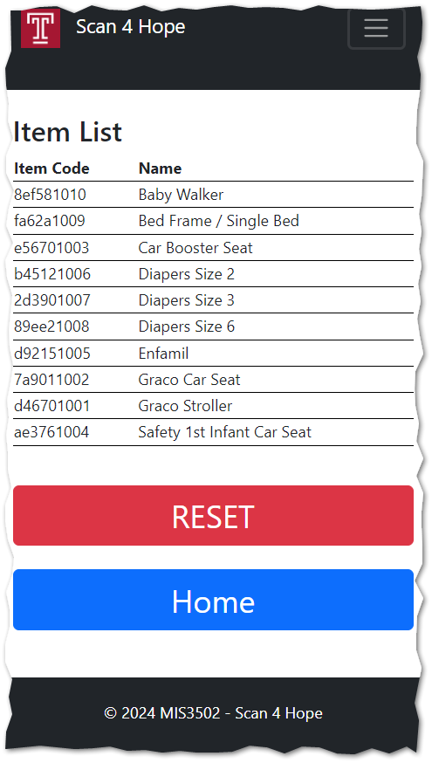

Clicking here will mark all items as available and refresh the table above.

Content changes with checkout activity.   
  
Items disappear from the list when checked out, and the UI is reloaded.