The QR codes on the following pages were generated using the GOQR API found here:
QR codes generated here:
https://goqr.me/
These codes are big enough to be scanned by a regular laptop Web Camera. But they would be a little too big to be printed on a product label. So, they are good for testing, but not ideal for the actual, production use case.

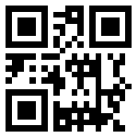
d46701001
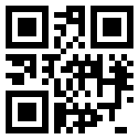
7a9011002
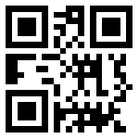
e56701003

QR codes generated here:
https://goqr.me/

