# Project 1 –Setups, Date and Time Application

## PLEASE LIST YOUR NAMES

## (You and your project partners)

|  |
| --- |
| NoName McHiggens |
| Ima Test |
| Sam Student |
| Anne NotherWon |

## Expectations

* Instructor Guidance – High
* Independent Effort – **Moderate**
* Originality – Low
* Teamwork – Low

Be advised that every member of your project team should expect to receive the same grade on this project. That means that the mistakes of one student can bring down the grade of the whole team. Students are expected to help their project buddies and check each other’s work.

## Description

To build a web application, you need to “cook” with many “ingredients”. You need client-side code, web service code, and (usually) a database.

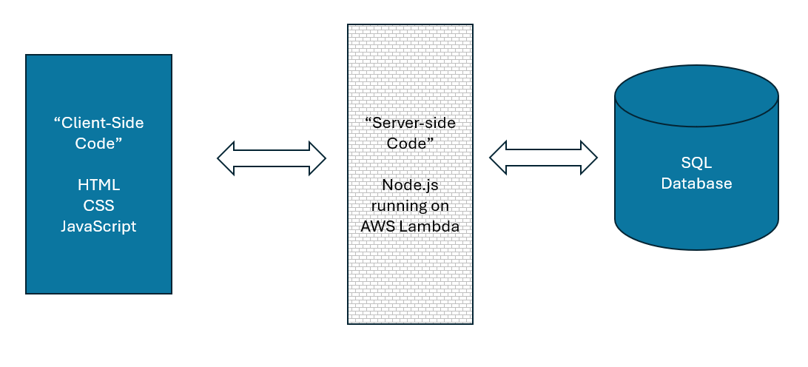

This project (Project 1) steps students through the process of creating a very simple web application that has each of those “ingredients”. The final product will be a page that displays the current date and time in Philadelphia. We are using ***a lot*** more technology than is necessary to do this. (This is what’s known as an “over architected” solution!)

However, the process of doing so will help students envision the purpose of each “ingredient” and will also ensure that each student has done all the setup work necessary for future projects in the class.

Getting your own computer set up and getting ready to go is important, and this is the chief objective of this project.

While this project (Project 1) is a team project, each student is expected to do these installations for themselves, on their own computers. If you fail to do this work for yourself then you will: *struggle* to follow along in class, *struggle* to contribute to future projects, and consequently *struggle* with quizzes and exams.

Finally, be advised that at the end of this project there is new content dedicated to setting up GitHub CoPilot. It is very important that you do this, even though that new content is not graded this semester.

## Instructions

1. Did you notice the “PLEASE LIST YOUR NAMES” box at the very beginning of this document? If you haven’t already done so, replace “NoName McHiggens” and the rest of the silly names with your name, and the names of your project buddies.

|  |
| --- |
| Students should plan on turning in ***one*** document to represent the work of the whole team. It would be wise to set this document up as a shared document so that you and your buddies can all edit it together, each student adding their own part.  One of you will be “student 1”, the next will be “student 2”, and so on.  I expect you to help each other. If you get stuck, reach out to your project buddies for help! |

1. Delete your old AWS account from last semester. There is no reason to keep your old AWS account (from the Cloud Architecture course) for the sake of this class (Web Service Programming). ***I want students to delete their old free tier account and make a new one.***

If you have some reason for keeping your old AWS account active (like, you have personal work out there, or you need it for some certification you are studying for) then let your instructor know. You can send me mail at [jeremy@temple.edu](mailto:jeremy@temple.edu).

See this video: (Deleting your old account) <https://youtu.be/TG8wS6D6bJs> (~ 4 mins)

1. Make sure Visual Studio Code is installed, and that you know where your local workspace folder is.

See this video: (VS Code and your local workspace) <https://youtu.be/PJzX5QMrNuQ> (~ 8 mins)

**<< EACH STUDENT SHOULD COPY / PASTE A SCREEN SHOT HERE >>**

**<< STUDENT 1 >>**

**<< STUDENT 2 >>**

**<< STUDENT 3 >>**

**<< STUDENT 4 >>**

1. Make a new AWS (free tier) account for this semester. Set up a public S3 bucket and validate that it works.

See this video: (Your new AWS account) <https://youtu.be/TfGbGD8hBio> (~ 15 minutes)

Student 1: Put the URL to your “Hello Word” page here:

|  |
| --- |
|  |

Student 2: Put the URL to your “Hello Word” page here:

|  |
| --- |
|  |

Student 3: Put the URL to your “Hello Word” page here:

|  |
| --- |
|  |

Student 4: Put the URL to your “Hello Word” page here:

|  |
| --- |
|  |

1. Using your new AWS account, create two sets of AWS Access keys.

The first access key will be yours for your personal, individual use.

The second access key be shared with other students, later in the semester, for group work.

See this video: (Make a new account) <https://youtu.be/YuKrfutoqg0> (~ 11 minutes)

Share both your keys with your instructor using this Google Form: <https://tinyurl.com/shaferaws2025>

1. Install MySQL Workbench if necessary. (If you still have it from a prior semester, that’s fine.) Set up MySQL Workbench to point to the database server used by the class. Your instructor will provide the credentials you need.

Create your “blue” database using this command: CREATE DATABASE jXXXblue

See this video: (Setting up MySQL Workbench) <https://youtu.be/rMQ7VDZT1e4> (~ 11 minutes)

**<< EACH STUDENT SHOULD COPY / PASTE A SCREEN SHOT HERE >>**

**<< STUDENT 1 >>**

**<< STUDENT 2 >>**

**<< STUDENT 3 >>**

**<< STUDENT 4 >>**

1. Set up your project1 folder on S3.

See this video: (Upload and edit the client-side code for project 1)

<https://youtu.be/VHFwMaTQ8Qk> (~24 minutes)

|  |
| --- |
| ***REMEMBER*** – Control-Shift-R is better than a regular browser refresh. (Or Command-Shift-R on a MacBook) |

Student 1: Put your client-side code URL here:

|  |
| --- |
|  |

Student 2: Put your client-side code URL here:

|  |
| --- |
|  |

Student 3: Put your client-side code URL here:

|  |
| --- |
|  |

Student 4: Put your client-side code URL here:

|  |
| --- |
|  |

1. Set up your project1 function on lambda.

See these videos:

1. Getting ready <https://youtu.be/11bPGuvOWqM> (~10 mins)
2. DO NOT SKIP – SUPER IMPORTANT - Strategy <https://youtu.be/F-CCy8kw7LE> (~8 mins)
3. Setting up your lambda project <https://youtu.be/MzIb1fa-OmA> (~30 mins)
4. Edit your lambda code with VS Code <https://youtu.be/pgvkGkDr5xY> (~20 mins)

Student 1: Put your web service endpoint URL here:

|  |
| --- |
|  |

Student 2: Put your web service endpoint URL here:

|  |
| --- |
|  |

Student 3: Put your web service endpoint URL here:

|  |
| --- |
|  |

Student 4: Put your web service endpoint URL here:

|  |
| --- |
|  |

1. Put it all together and validate that everything works.

See this video: (Check your work)

<https://youtu.be/ttlzU3xka7E> (~ 10 minutes)

**<< EACH STUDENT SHOULD COPY / PASTE A SCREEN SHOT HERE >>**

**<< STUDENT 1 >>**

**<< STUDENT 2 >>**

**<< STUDENT 3 >>**

**<< STUDENT 4 >>**

**CONTINUED**

## Turn in your work!

When you are done, upload this document to the corresponding “Project 1” assignment out on canvas. One document per team, please.

## Wait, wait! You are not done!

I am adding this new content for setting up GitHub Co-Pilot. This is the AI “magic” that you will need to use this semester. So, even though there is not screenshot required here, I will expect you to complete this work before we begin Project 2.

* Set up your GitHub Account <https://youtu.be/aRoiZuaxtYE> (~ 6 minutes)
* Set up the VS Code extension <https://youtu.be/WyJqr0xgygc> (~ 6 minutes)

|  |
| --- |
| ***Be a team player*** – Remind your project buddies to do this! |

## How will this project be graded?

Be advised that every member of the team will get the same grade and that one student’s error can bring down the grade of the whole team. Student’s should help each other, and check each other’s work.

|  |  |
| --- | --- |
| Item | Points |
| ***All*** your names / Step 1 | 5 |
| ***All*** your screenshots / Step 3 | 10 |
| ***All*** URLs provided / ***all*** work / Step 4 | 10 |
| Access keys reported on a Google form / Step 5 | 40 |
| ***All*** your screenshots / Step 6 | 10 |
| ***All*** URLs provided / ***all*** work / Step 7 | 10 |
| ***All*** URLs provided / ***all*** work / Step 8 | 10 |
| ***All*** your screenshots / Step 9 | 5 |
| **TOTAL** | 100 |

Please see the syllabus for the late policy.