Project 4 – Building a UX/UI for a “To Do” application

PLEASE LIST YOUR NAMES

(You and your project partners. Same as in Project 3)

Expectations
- Instructor Guidance – Moderate
- Independent Effort – Moderate
- Originality – Low
- Teamwork – High
Be advised that every member of your project team should expect to receive the same grade on this project. That means that the mistakes of one student can bring down the grade of the whole team. Students are expected to help their project buddies and check each other’s work.

Description
This project (Project 4) will step students through the process of creating a web UX/UI to interact with a database resource through a web service. This simple “to do” list web application will allow users to login, see a list of “to do” items, add items to a list, and remove items from the list.
This is the final project document. Record your names at the top of this page. Fill in the boxes below. Turn this document in: one document per team.

Instructions
- In this project, we walked through two “warm up” activities in class. The instructions in this document assume that you have followed along in class and performed the “warm up” activities. If you have fallen behind, please work with your project buddies to get caught up!
- As stated in class, in this project it is acceptable for all project buddies on a team to share the same endpoint URL. You may not, however, use Shafer’s endpoint in your final project submission.
- Be smart! It is highly recommended that each member of your project team adopt a persona … one of the users in the users table. So, one of you can be “sally” and the other can be “joe” and the other can be “bob” and so on. You are welcome to add records to your users table in MySQL. But, please, don’t delete the original usernames and passwords I provided to you there.
- Before you write any new code, prompt Copilot and ask it to evaluate if your code complies with the README.md file. If it doesn’t you will need to ask Copilot to make fixes
- Use the artifacts found in this document to complete the application. This means implementing the task list and view task portions of the user experience. When you are done, you solution should look like this:
https://youtu.be/18LJPjQSXFI and this https://youtu.be/Ob08ViQjn9M
  - Note that the “edge case” condition where all tasks are completed is managed nicely.
  - Note that the task list that “bob” sees will be different from the task list seen by any other user. That is the point of the login, right? Different users see different tasks.
  - Notice that error messages only appear when appropriate, and that they disappear when no longer relevant.
  - Error messages always appear in the same place, above the buttons.
  - The visual elements are laid out consistently and cleanly, with sufficient white space around each element.
- Upload your work to S3. Determine the URL to your work. Copy/paste your URL into one of the boxes below.

- Test your work thoroughly. Test the work of your project buddies thoroughly. If you see something odd, inaccurate, misleading, or misaligned, call them on it. Work together. Get it fixed.

- Check for broken/bad HTML using Firefox view page source.

- Check for Critical A11y errors with WebAim. This includes contrast errors. Make fixes where needed.

- Check that your code conforms to the README.md file. Make fixes where needed.

- Turn in this document on Canvas.

Rubric
Point deductions are assigned in 5-point increments.
Item | Points
All your names | 10
All URLs provided | 10
All UI Features work | 50
All HTML is valid | 10
No A11y errors | 10
Conforms to README.md conventions | 10
TOTAL | 100

Please see the syllabus for the late policy.

Artifacts

UI Mockup Sketch
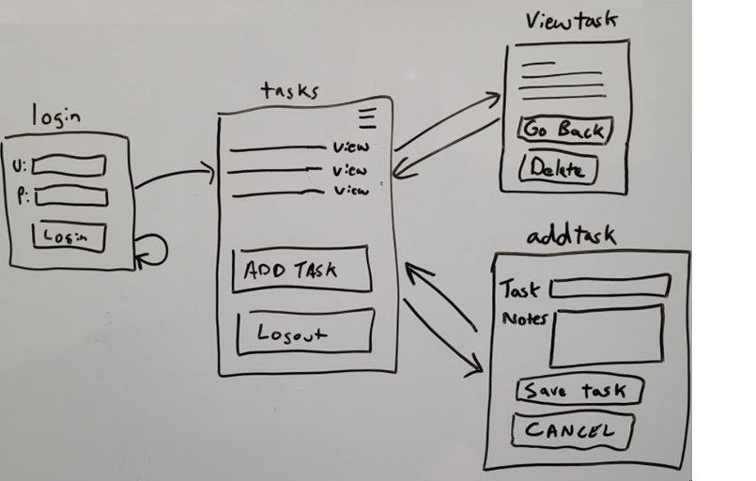

CONTINUED

Shafer’s Prompts
You will need more than just these prompts to complete the project. However, I give you these prompts to get you started. I strongly recommend that you type them in to Copilot.
Also, please note that I made a steady commitment to provide index.html, README.md and app.js as context with each request.
As I worked on this, I found that “Agent” mode was working well. Students are welcome to try “Agent” mode instead of “Ask” mode.
Here are prompts that I wrote, in the order that I wrote them.
