Project 3 – Building a Web Service for a “To Do” application

PLEASE LIST YOUR NAMES

(You and your project partners. Please note that you have new project partners!)

NoName McHiggens

Ima Test

Anne NotherWon

Expectations
- Instructor Guidance – High
- Independent Effort – Moderate
- Originality – Low
- Teamwork – Moderate
Be advised that every member of your project team should expect to receive the same grade on this project. That means that the mistakes of one student can bring down the grade of the whole team. Students are expected to help their project buddies and check each other’s work.

Description
This project (Project 3) steps students through the process of creating a web service that interacts with a database resource through a web service. The service will ultimately be used to build a simple “to do” list web application, that will allow users to login, see a list of “to do” items, add items to a list, and remove items from the list.
The user interface for the application will be developed in project 4. The focus of this project (project 3) is on building the web service.
This project introduces students to a moderately sophisticated login mechanism, a web service that appropriately uses HTTP methods, and give students more experience writing code with (and without) AI assistance.

Instructions
- Did you notice the “PLEASE LIST YOUR NAMES” box at the very beginning of this document? If you haven’t already done so, replace “NoName McHiggens” and the rest of the silly names with your name, and the names of your project buddies.
Students should plan on turning in one document to represent the work of the whole team. It would be wise to set this document up as a shared document so that you and your buddies can all edit it together, each student adding their own part.
One of you will be “student 1”, the next will be “student 2”, and so on.
I expect you to help each other. If you get stuck, reach out to your project buddies for help!

- If you haven’t done so already, install the Thunder Client extension in VS Code. You need this because you can only test GET requests in a browser. To test other methods (POST, PUT, PATCH, DELETE) you need either a utility like Thunder Client, or you need to write your own client code.
- Testing is part of this project, and without Thunder Client, you won’t be able to test sufficiently.
- Using a utility like Thunder Client is usually easier than, and more reliable than, writing your own client code.
- You will write your own client code in Project 4.
- Set up the database. (We did all this in class. If you weren’t in class, get help from your buddies.)
  - Download project03db.zip and unzip project03db.sql onto your local filesystem
  - In MySQL Workbench, connect to the class server.
  - In MySQL Workbench, create a gold database with the CREATE DATABASE command
  - In MySQL Workbench, USE the database that you just created
  - In MySQL Workbench, open the project03db.sql script and run it. This will create three tables as illustrated below.
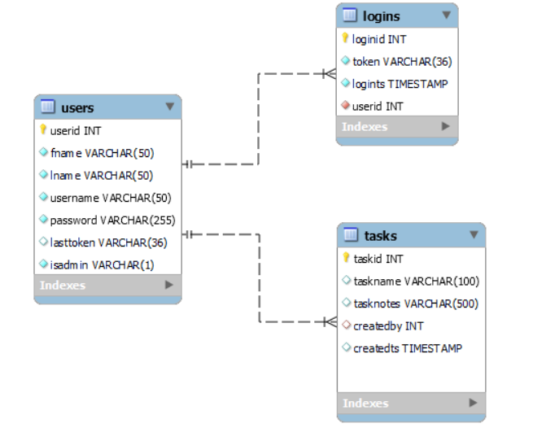

If you accidentally mess up your database, you can always rerun the database creation script in your “gold” database. That will delete all the old / bad tables and recreate the data. This puts the database back to its original condition.

- Set up the web service. (We did all this in class. If you weren’t in class, get help from your buddies.)
  - Download the lambda client zip file: project3-lambda-template.zip. Do not unzip it.
  - Create a new project 3 lambda function out on AWS. Name it project3lastname where lastname is your last name (for example: project3mchiggens).
  - Upload the template zip file into the new lambda function. (You must upload the whole zipped file.)
  - Specify your database credentials. Perform a test.
  - Specify your REST API gateway. Perform a test.
  - Specify your REST API Proxy gateway. Perform a test.
  - Perform a test POST to the login feature using the Thunder Client VS Code extension.
  - Edit your name in the “Created by” and “Last modified by” portions of the feature list.
- Use the “Open in Visual Studio Code” button on AWS to open your index.mjs file locally. Test that VS Code and GitHub Copilot are working correctly.
Be sure to prefix every AI request with @workspace
- Create these features. 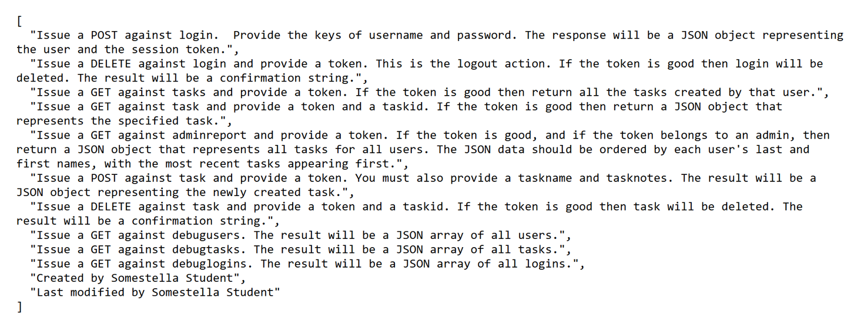
Be sure to remove the myname and datetime features before you turn in your work. That means, for each feature, you remove the feature from the features list, you remove the condition from the routing function, and you remove the supporting function.
You could ask the AI to do that, but deleting things is usually pretty easy for a human being to do. It would be smart to make those edits yourself.
- (Programming conventions) When you think you are done, check your work against the README content and remediate: You want your final product to be consistent with MIS3502 programming conventions in the README documentation.
How do I do that??? You ask Copilot! You could say something like:
@workspace please verify that this code conforms to all the conventions in the README file documentation.
- What about A11y? In this project you are not required to perform an A11y assessment. (There’s no UI.)
- What about security? In this project you are not required to perform any sort of security assessment.

- Each student should provide the URL for their work.
Student 1: Put your Lambda web service URL here:
Student 2: Put your Lambda web service URL here:
Student 3: Put your Lambda web service URL here:

- Test your own work. Your instructor should be able to visit each one of the links above and, using the Thunder Client, perform the expected operations on each advertised feature. That includes login, retrieving tasks, add tasks, and removing tasks.
A user should be able to logout with the logout feature.
The administrator report should work as specified and the report feature should only work for users with the admin flag set to ‘Y’.
- Did you test and validate the work of your buddies? You should, using Thunder Client, test the work of your project buddies. Test their work at least as vigorously as you tested your own. If you find a mistake, it’s up to you to communicate, collaborate, and help your project buddy bring the problem to resolution.
Remember, you are all in this together.
- Turn in your group work. On Canvas, turn in this completed Word document (one per team).
- Turn in your individual work. Each individual student should copy and paste their index.mjs code into the Project03-Code-Artifact on Canvas. The code submitted should conform to the MIS3502 programming conventions in the README documentation.
If you are not sure how to do that, you can watch this video:
https://youtu.be/y1AJ0A1kOik

How will this project be graded?

Be advised that every member of the team will receive the same grade and that one student’s error can bring down the grade of the whole team. Students should help each other and check each other’s work.
After the due date there will be no opportunity for resubmission or revision.
CONTINUED

Point deductions are assigned in 5-point increments.
Item | Points
All your names | 10
All URLs provided | 10
All Features Web service Features work | 50
All code provided - Each individual student should copy and paste their index.mjs code into the Project03-Code-Artifact assignment on Canvas. The code submitted should conform to the MIS3502 programming conventions in the README documentation. | 30
TOTAL | 100

Please see the syllabus for the late policy.

