MIS3506 – In Class Activity – Week 1
In breakout sessions, students will select and navigate to various websites.
Part 1: Breakout Session
Student 1 (The Observer) will select and name the website and observe student 2 as they navigate through it
Student 2 (The Navigator) will open that website and then use the following questions as a guide.
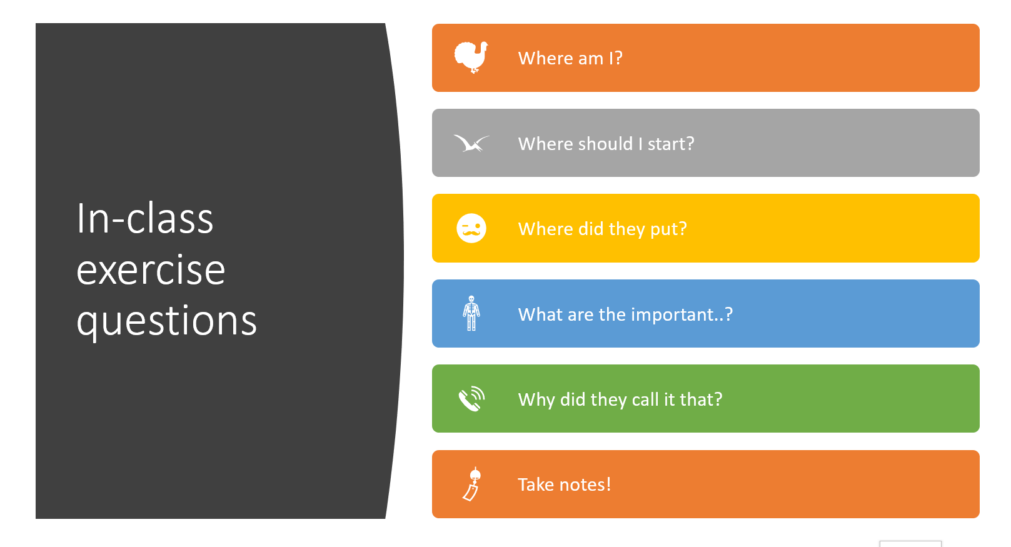
The observer should provide tasks for the navigator to complete, such as add something to your shopping cart, play a game, search for xxx, create a new chat… The observer should not provide guidance on how to complete the task but observe while the navigator figures it out
The navigator should speak out loud while working through the site, using the above questions (and others) to frame out your thoughts
Be prepared to discuss:
- How was the overall UX of the site?
- What was tough about being the observer?
- What was tough about being the navigator?
Part 2: Class Discussion

