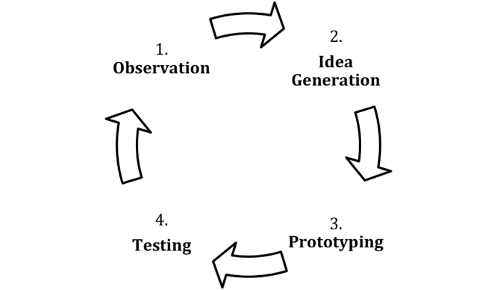
In Class Activity: Design Thinking in Action (60 Minutes)
Step 1: Decide/understand the problem/opportunity (5)
Random Breakout Sessions
Step 2: Ideate – Brainstorm ways to solve your problem/meet the opportunity (10)
Step 3: Prototype – Select the best ideas from your brainstorm. Create a three-screen prototype that showcases those ideas (10)
Main Session
Step 4: Test your prototype by allowing others to utilize your prototype. Give the testers some tasks. Do they perform the actions as you would expect? (10)
Back to Breakout Sessions
Step 5: Create an updated version of your prototype, based on testing (10)
Step 6: Present your idea to the class (15)

Problem/Opportunity: The MS-Digital Innovation in Marketing Program provides an excellent Master of Science degree focused on the integration of technology and marketing. Prospective students should be able to do several things on their website – find out information about curriculum, cost of attendance and length of the program. Prospective students should be able to register for an upcoming information session, contact the program director and see jobs that graduates hold. Prospective students should also be able to request more information. There may be a few other things students who are researching a degree may want to do, but the director is not sure. They should be able to do this on a pc, mobile phone or tablet. The department does not want to maintain multiple sites. Students should not have to download an app to get this information.

