MIS3506
ICA: Problem Identification and Project Research
Goal: Research a company, identify key requirements and users, present back to the class
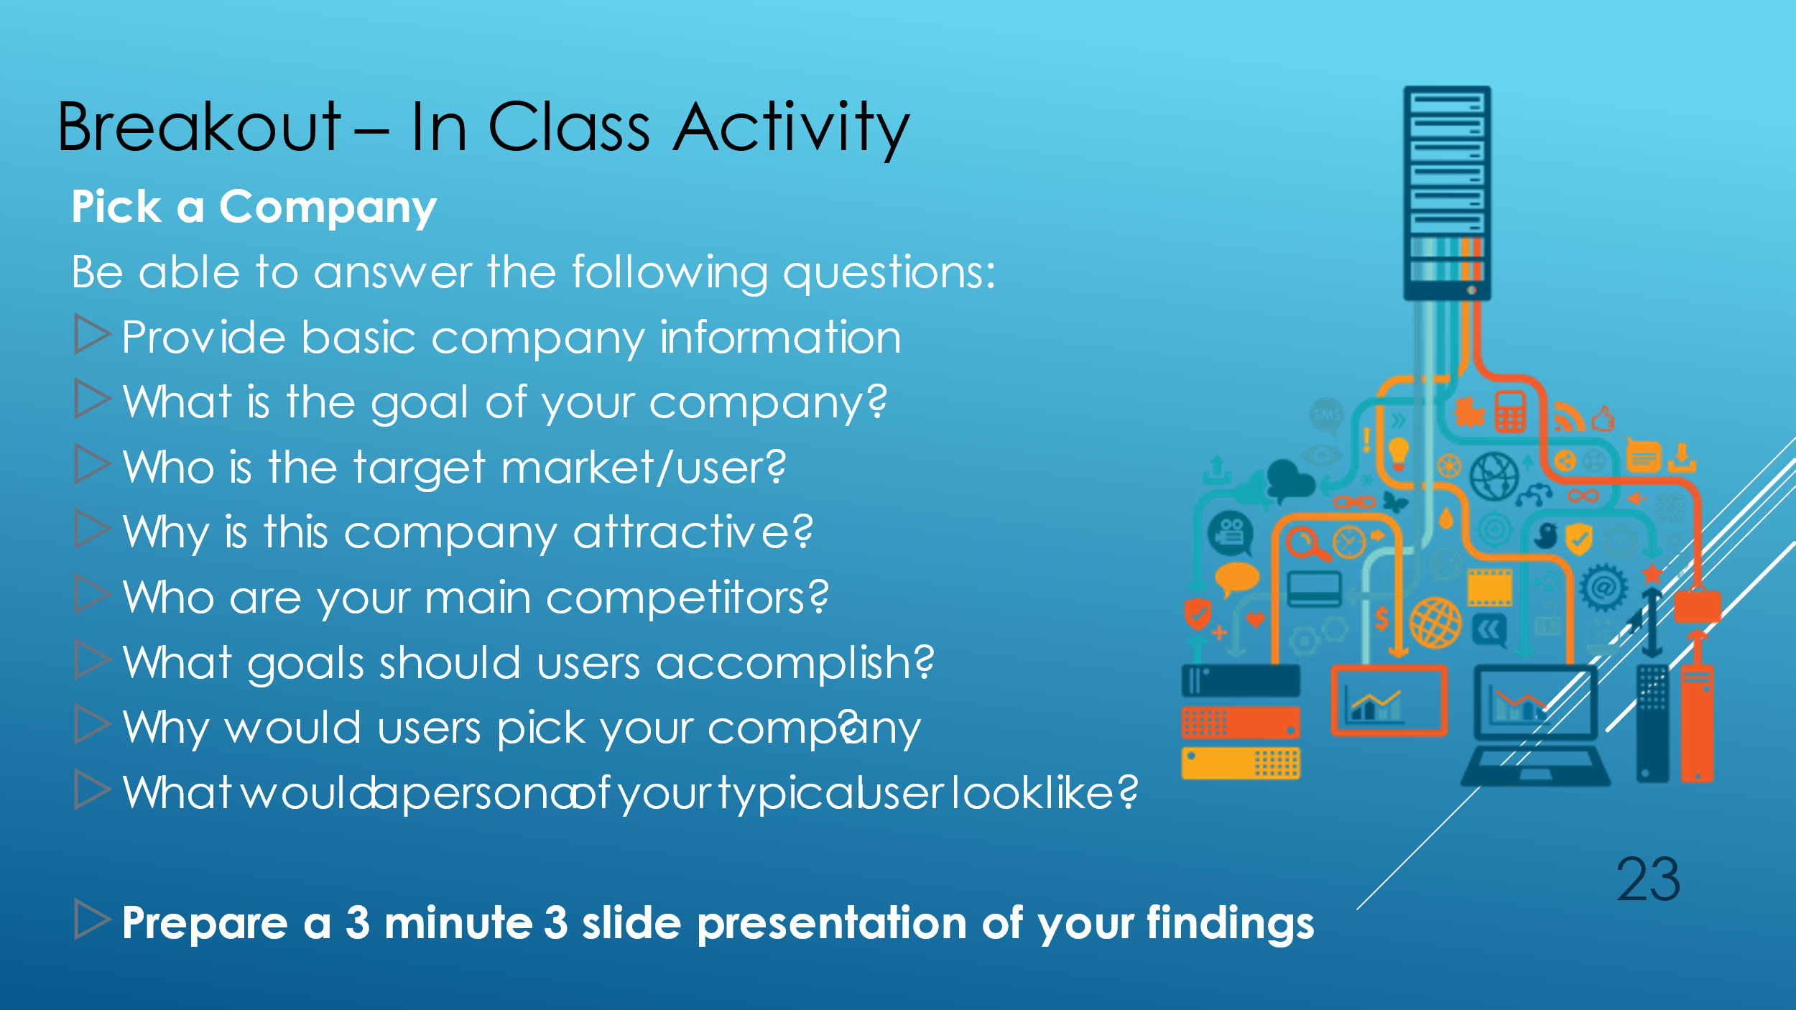

Students will be placed in breakout rooms and assigned a company to research
- Breakout session: With your team, review the site and prepare a presentation to report back to class. Your assigned company will come from this site: https://www.visualcapitalist.com/top-50-most-innovative-companies-2020/
  - Your team should pick the number that corresponds to whatever Breakout Room number you are assigned.
- Class Discussion: Teams will be chosen at random to present their findings

