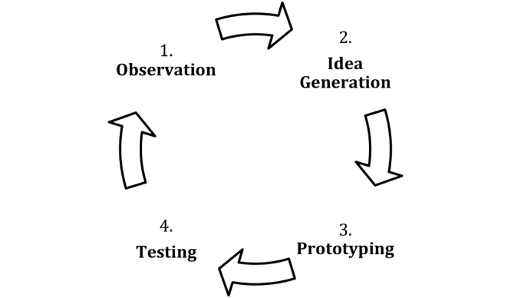**In Class Activity: Design Thinking in Action (60 Minutes)**

Step 1: Decide/understand the problem/opportunity (5)

Random Breakout Sessions

Step 2: Ideate – Brainstorm ways to solve your problem/meet the opportunity (10)

Step 3: Prototype – Select the best ideas from your brainstorm. Create a three-screen prototype that showcases those ideas (10)

Main Session

Step 4: Test your prototype by allowing others to utilize your prototype. Give the testers some tasks. Do they perform the actions as you would expect? (10)

Back to Breakout Sessions

Step 5: Create an updated version of your prototype, based on testing (10)

Step 6: Present your idea to the class (15)

**Problem/Opportunity**: TUPortal is the main hub for resources at Temple University for students, staff and faculty and has recently been redesigned. First time students should be able to locate their courses, find their schedule, and access Adobe Creative Cloud and Microsoft Office downloads with no problems. Students should also be able to join the IBC (gym membership) and access all the Temple University Applications with relative ease. There may be some other things students are trying to access, but the TUPortal designers are unsure. They should be able to do this on pc, mobile, or a tablet. Students should not have to download any additional apps to get the information they need. Use our design thinking principles to make TUPortal better.

Tuportal.temple.edu