MIS3535: WordPress instructions

The instructions below detail how to set up a basic site with a theme on WordPress through the MIS community site. The MIS server allows you to create a free WordPress account.

- Navigate to the community site here: https://project.mis.temple.edu/
- Click “Log In” in the top left and use your TU credentials
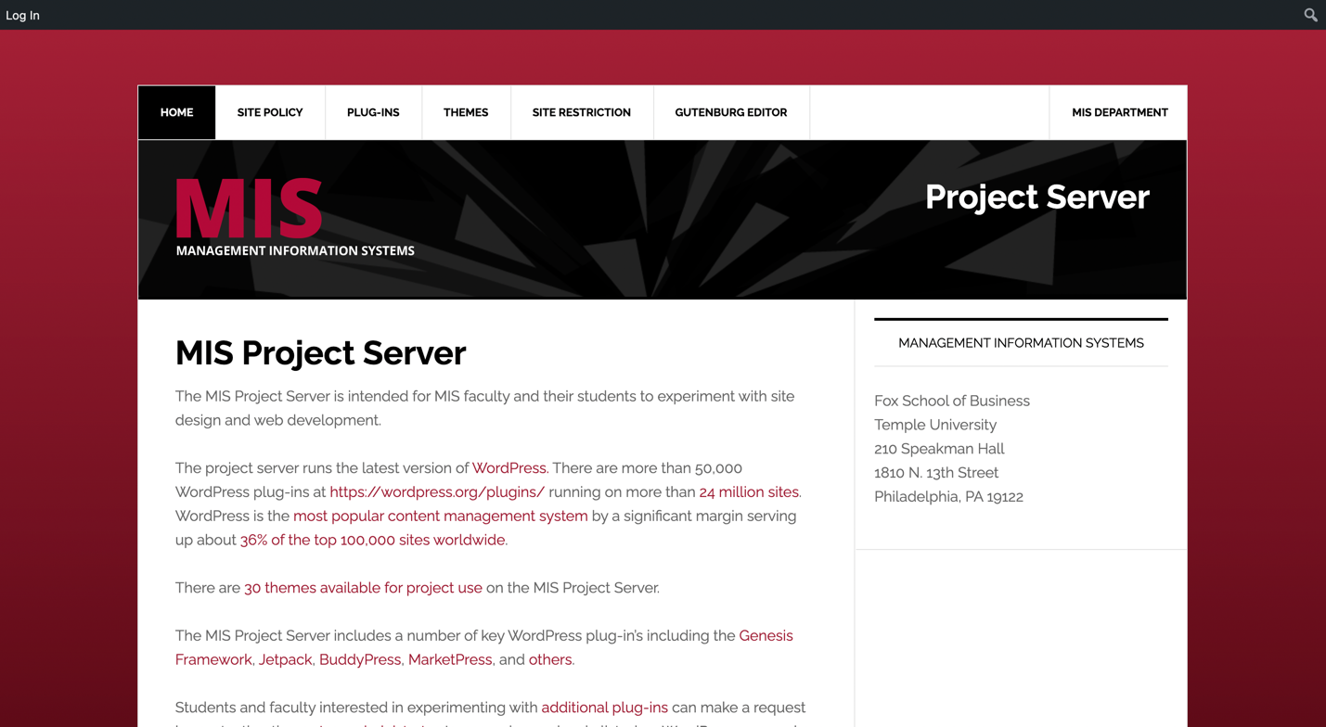

- Hover on your TU email 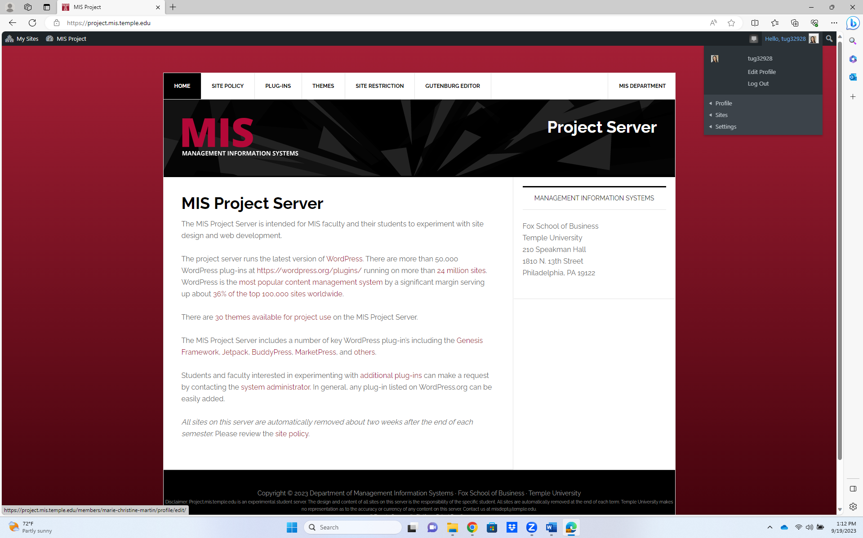

- Click “Site” then “Create a Site” to start creating your site. 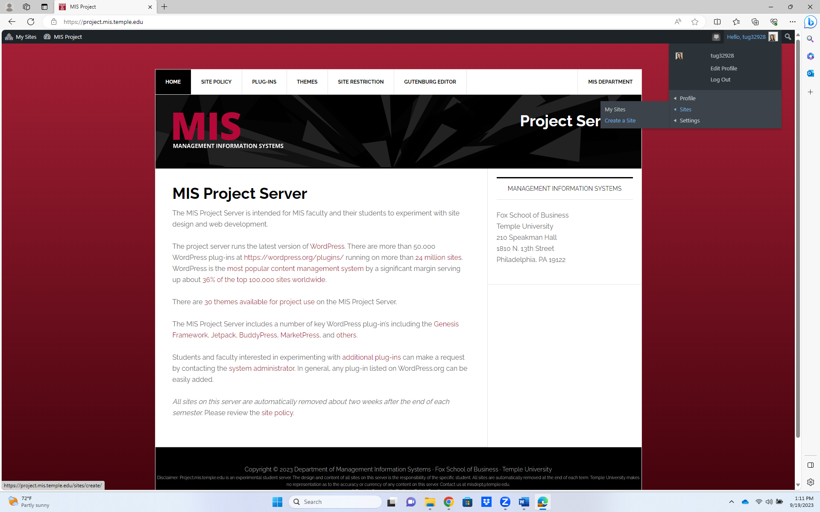

- Here you will enter all the basic information including the URL directing traffic to the site (could be a company name), the Site Title (also company name), and privacy settings. Finally hit “Create Site” at the bottom.
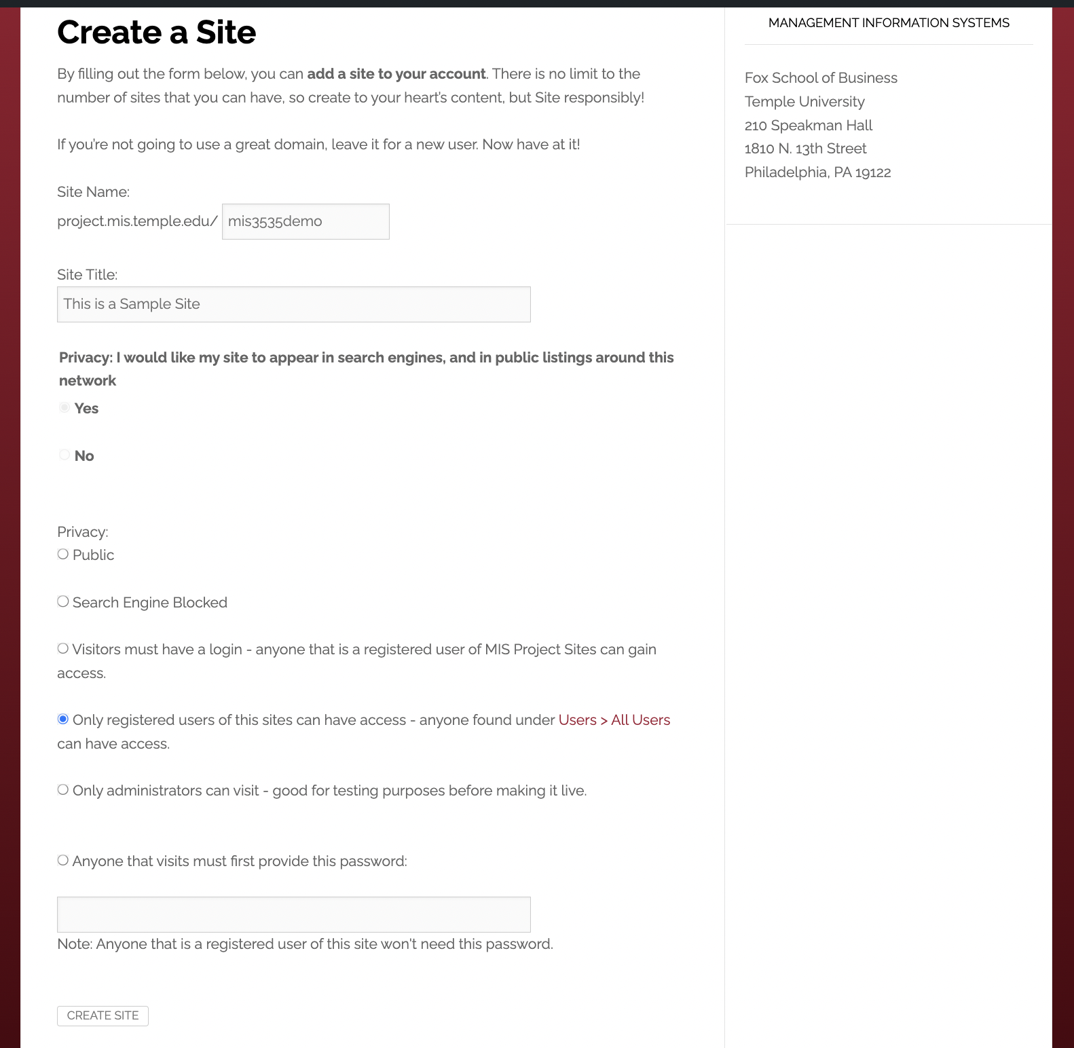

- You should see a pop up saying “Congratulations on creating your site.” Navigate back to “My Sites” in the top left. Click on Dashboard for your created site.
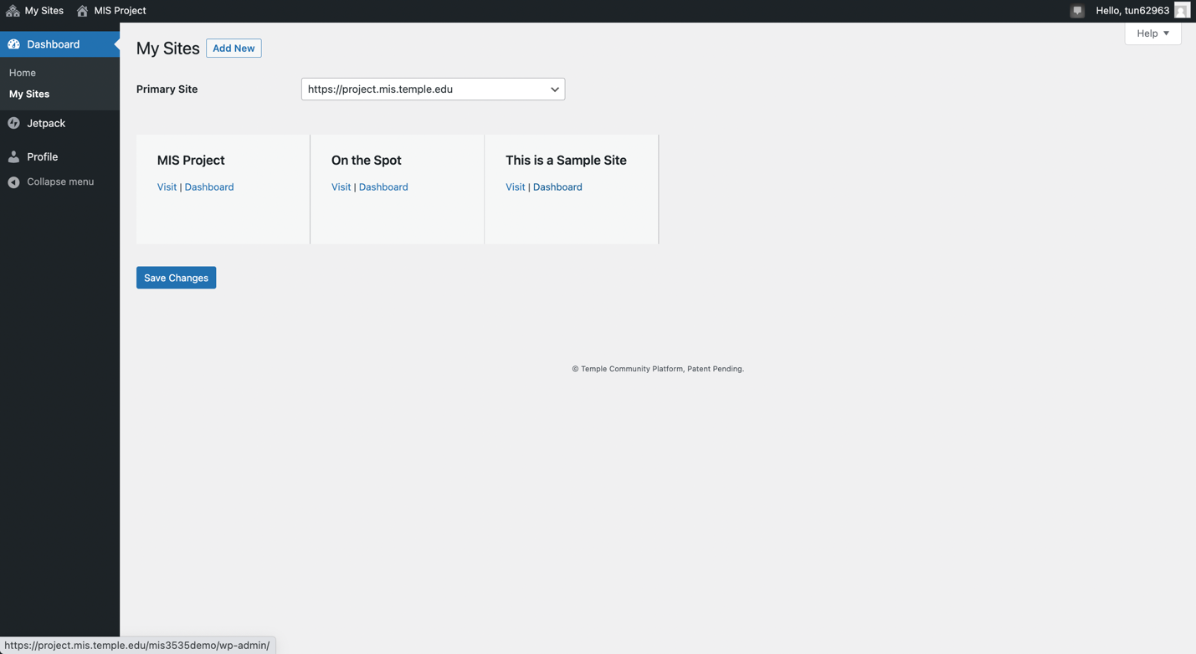

- On the side menu hover over Appearance and Select “Themes”
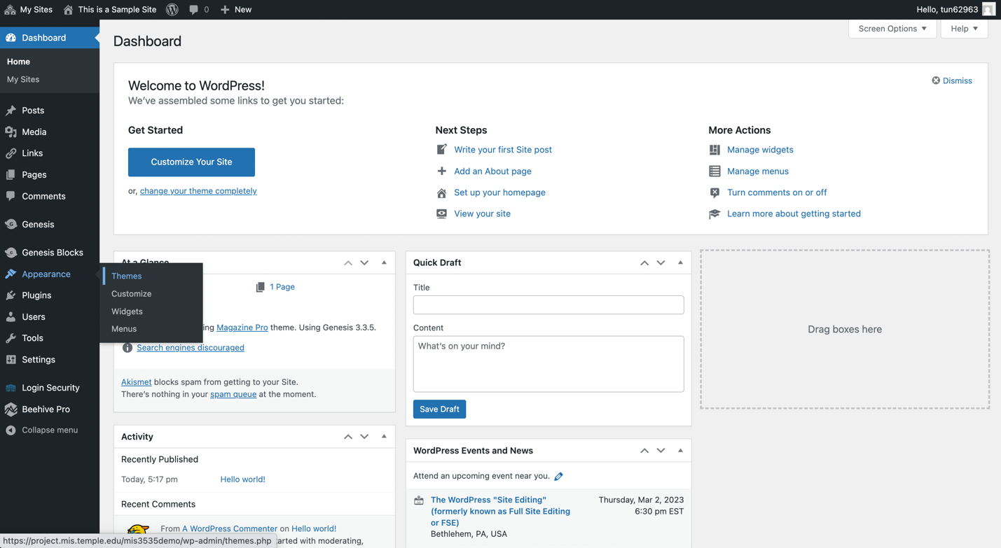

- Here you can select one of nine themes for your site. From there you can customize the colors and layout of the site.
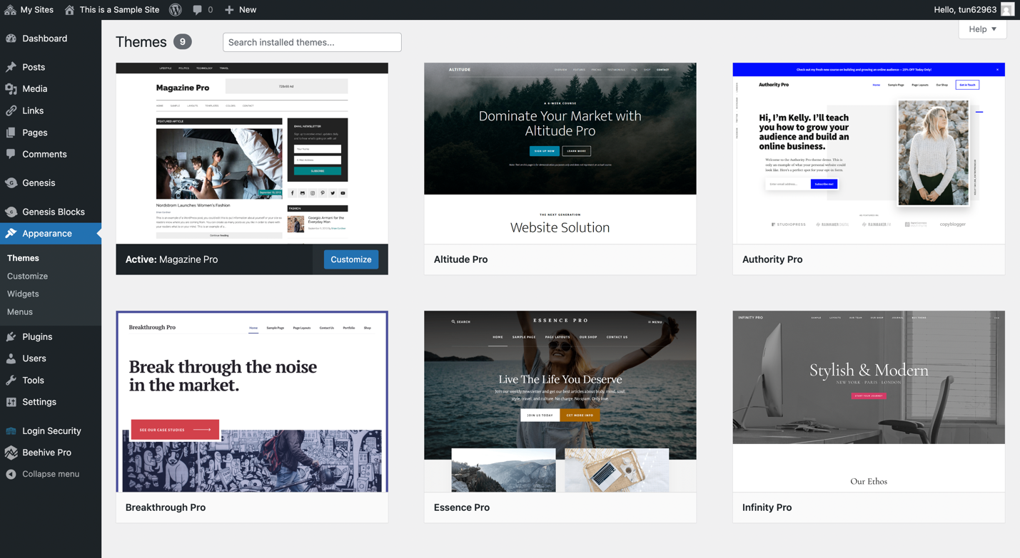

- Here are some tutorials to help guide you through WordPress:
  - https://www.linkedin.com/learning/wordpress-5-essential-training/wordpress-an-introduction?autoplay=true&u=2206009
  - https://www.linkedin.com/learning/learning-genesis-for-wordpress-2/getting-started-with-genesis?autoplay=true&u=2206009
  - Note: The MIS site has a few preapproved WordPress plugins. Additional plugins may need professor and department preapproval.

