MIS3536 – Information Systems Innovation with AI

Study Guide – Exam 1 – Spring 2025

The exam will be comprised of 50 multiple choice questions. The questions will be worth two points each. The exam will be paper-based, and students will report their answers using a SCANTRON.
Exam 1 is a closed book, closed note exam. Students will be given the full class period to complete the exam.
Students should review the material we have studied up until this point in the semester. The following diagram is offered as a form of overview. Students should be familiar with the terms used in this diagram.
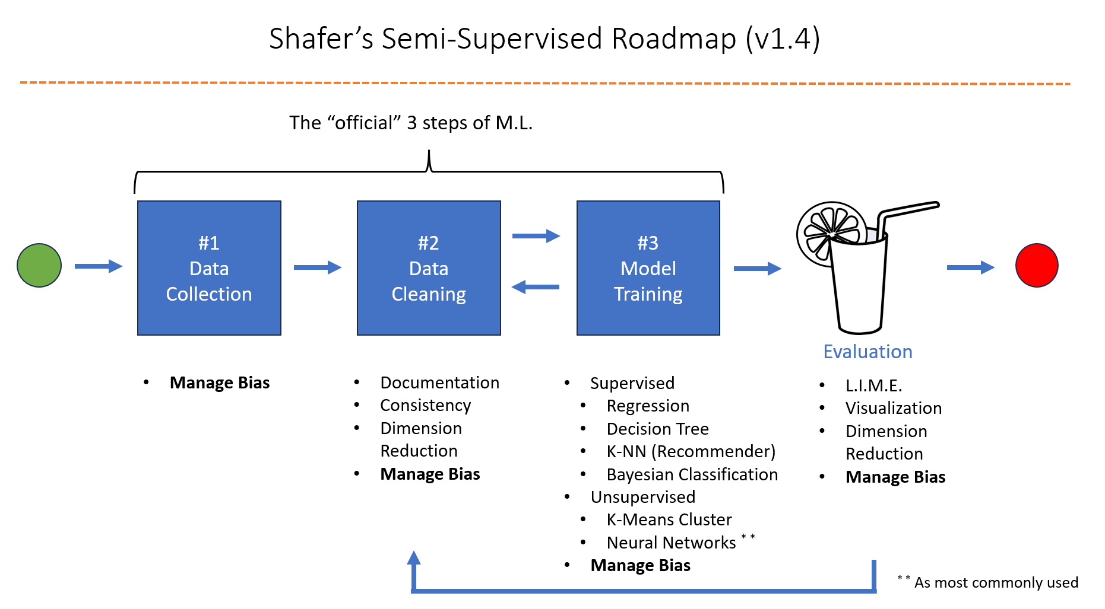
The exam questions will be derived from material found in the lectures.
The exam will not directly/deliberately reference and of the “Long reads” Case study discussions.
There is a natural overlap between the content of the activities, assignments and the lecture materials. Students should treat the lecture materials as the primary source of information.
Students will not be expected to answer questions related to specifics related to Python code.
Students should study material found in the following:
01 MIS3536-AI-ML-DL.pptx
02 MIS3536-Supervised-vs-Unsupervised-Learning.pptx
03 MIS3536-Interpretability.pptx
04 MIS3536-Managing-Bias.pptx
05 MIS3536-LLMs.pptx

