# In Class Activity

## LLMs and Coding – Activity 7

In this activity we will use ChatGPT to create simple web applications. Even students with no coding background should be able to accomplish this task!

Web pages typically use a mixture of programming languages, not just one. Minimally, a modern web page will have these three languages, working together: HTML, CSS, and JavaScript.

HTML (Hypertext Markup Language) is what gives a web page its overall structure.

CSS (Cascading Style Sheets) is the language used to specify the appearance of HTML elements. CSS controls things like size, shape, font, and color.

JavaScript is a general-purpose programming language used to respond to user actions, perform calculations, and/or manipulate the HTML and CSS on a web page.

ChatGPT can generate all of the above for you!

## Instructions

1. Get yourself a free codepen.io account. We will use codepen.io to edit and host our HTML, CSS, and JavaScript. The URL for codepen.io is <https://codepen.io>

In CodePen, the term "pen" refers to individual projects or code snippets that users create. The name "pen" is a playful and concise way to describe a small, self-contained piece of code that can include HTML, CSS, and JavaScript. It is analogous to a sketchpad or notebook where developers can quickly jot down and experiment with code ideas.

1. Once you login, click on “Pen” under the “Create” menu option.

1. In your new Pen, click the pencil icon next to the word “Untitled” and change the title to “Pizza”.

1. Now, sign into ChatGPT. Get yourself a free (or paid) ChatGPT account if you don’t have one already.

<https://chat.openai.com>

1. Ask ChatGPT to create a web page for an imaginary business: Cheesy Pete’s Pizza Palace. Copy/Paste the resulting code into the HTML panel of your “Pizza” pen.

1. Click the “Save” icon.
2. Now, click the “Change View” icon and choose the “Debug mode” view. This will present to you a full screen preview of your web page.

1. Copy / Paste the debug URL to your work into this box:

|  |
| --- |
|  |

1. OK…. That was just the warmup! A web page is just static web content. It does not change in response to user input. What if we wanted to create a web ***application***? A web application changes dynamically in response to user-initiated events.

Click on the CodePen icon to go back to your home page dashboard.

1. Make a new pen (click on “Pen” under “Create”).
2. Name this pen “Calculator”.
3. Ask ChatGPT to use HTML, CSS, and JavaScript to create a four-function calculator. A four-function calculator is a basic type of calculator that can perform the four fundamental arithmetic operations: addition, subtraction, multiplication, and division. These calculators are typically simple and straightforward, designed for basic mathematical tasks. They do not include more advanced functions like trigonometric calculations, logarithms, or statistical operations.
4. Again, copy/paste your code into the HTML panel. You might need to clean up the code a little bit to get a satisfactory result. You can ask ChatGPT to make revisions for you or, if you have rudimentary coding knowledge, you can make the changes yourself.

I was able to get a result that looked like very quickly.

1. When done, click on “Change View” and “Debug mode” again. Put the URL to your calculator work in the box here:

|  |
| --- |
|  |

1. Now that you have a feel for this…it’s time to get creative! Ask ChatGPT to use HTML, CSS, and JavaScript to make a web version of a classic arcade game. For example, I asked for a JavaScript version of the game breakout, and got a functioning game that looked like this:

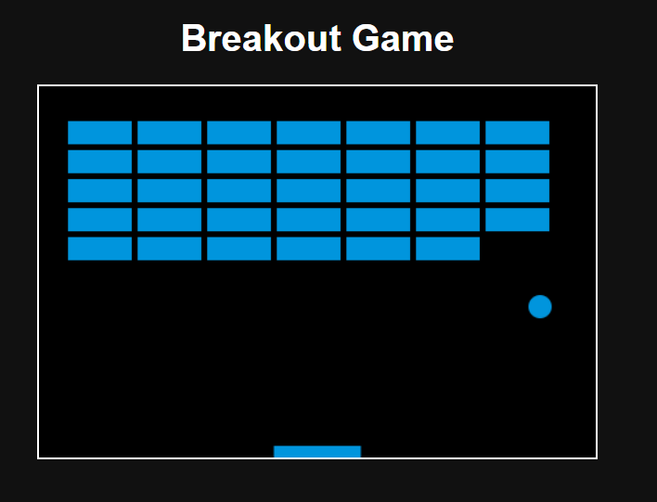

You are in no way limited to the “Breakout” idea … make a simple game that you think is fun to play!

1. When done, click on “Change View” and “Debug mode” again. Put the URL to your calculator work in the box here:

|  |
| --- |
|  |

1. Finally, you need to do three things.
   1. Save and upload this word document to canvas Activity 7 on canvas.
   2. Copy/paste your video arcade game URL to the Canvas discussion “Arcade Games” and provide a brief description of it.
   3. Look at the games your peers made. Vote for your favorite game using this Google Form here:

<https://forms.gle/TNAM5xdorNrPp2bq7>