PUT YOUR NAME HERE: XXXXXXXXXXXXXX

MIS3536 Assignment 2 – Decision Tree

Instructions
- Type your name in the space provided above, replacing the X’s.
- Watch the assignment videos using the links in this document. In each video, you will be prompted to take a screenshot. Copy/paste your screenshot into this document in the spaces provided. Make sure that your screenshots are easy to read and show the expected content. If you don’t know how to take a screenshot, you can get help at this link here.
- Complete the last open-ended question, writing your answer in the box provided.
- When you are done, upload this Word document, and decion_tree.pdf to Canvas by the due date.

Dataset  - The dataset can be found here: https://www.kaggle.com/datasets/ritwikb3/heart-disease-statlog/data  - Go download the data set as a zip file ( archive.zip)  - Unzip the file and put the csv file into the same assignment02_ml_part_a folder we created in class previously.  The correct name of the file is Heart_disease_statlog.csv | 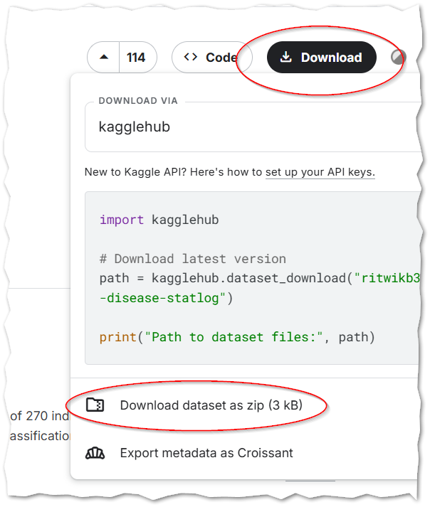
CONTINUED

Scenario
We are going to use this data set to help physicians determine if a patient has heart disease. The spreadsheet contains a column named `target` … if this column contains a `1` then the patient did develop heart disease. It contains a `0` if the patient did develop heart disease. The rest of the column names are documented on the Kaggle.com page under the “About the Dataset” heading.

Steps
- Open Anaconda Navigator, and Jupyter Notebook, just like we did in class.
- Using Jupyter Notebook, open the decision_tree.ipynb notebook file.
- Examine cell number 3. Edit INPUT_FILENAME, changing it from "dining_staffing_synthetic_500.csv" to "Heart_disease_statlog.csv”
- Examine cell number 4. Change “features to drop” as shown below.
#features to drop
#features = df.drop(columns = ['window_id','entries_next_30_min',OUTPUT_COLUMN])
features = df.drop(columns = [OUTPUT_COLUMN])

- Run the script with a max depth of 2. Interpret the tree. You will need to go back to Kaggle.com to know what the different variables mean.
What two variables predict, with over 90% certainty, that the patient has heart disease? Don’t just list the two variable names. Tell me what they mean.

- What is the correct classification rate of this tree with a depth of 2? Put your answer in the box below.

- Now run the script with a max depth of 4. What is the correct classification rate of this tree? Put your answer in the box below.

- Explain the difference between those last two classification rates in terms of one of the two Scaling Laws presented in class.

- What we have created is a single-use / one-time model. Consider what would be necessary to turn this model into a system that could be continuously improved.
Ideally, the system should learn and be retrained without the ongoing assistance of a human developer / programmer or analyst.
Propose a process for this sort of continuous improvement. I expect a paragraph or two of text here.

- Turn in this document, along with the last version of decision_tree.pdf that you created back on step 7.

