Put your name here: _________________________

Assignment 3

Detecting Bias

Advisory – Conversations and activities that deal with topics such as race, gender, human bias, and systemic bias are delicate things. Please regard this assignment as an attempt to help students analyze and interpret data in a responsible and constructive way. It was created with the belief that some classwork pertaining to bias detection would be better than none at all!

About the data – The data in this assignment is fake. It was originally generated by an AI (which, curiously, confused the notions of race and ethnicity) and then further randomized, refined, and modified to create a moderately convincing, yet completely imaginary, data set.

So what’s the point? – The point of the assignment is less about a specific model or approach and is more about a thought process. Two familiar Python scripts will illustrate how bias can influence an ML model, and how that bias might be managed.

Introduction
A survey was done of schools in the (completely imaginary) city of Rochadelphia. Demographic data was compiled from the students who took a math skills test. The purpose behind this effort was to determine what actions the educators in Rochadelphia could take to improve student math scores and math comprehension.
Your assignment is to follow the instructions, edit this word document, and turn it in on Canvas.
You will need to know how to take a screenshot and copy/past it into word. Kindly crop / zoom your images so that they are big enough to read.

Instructions
- Students should download assignment03.zip and unzip it into their mis3536workspace. The assignment03 folder contains three Jupyter notebook files, and one csv file: education_dataset.csv.
- Open education_dataset.csv in Excel. Be careful not to change it. Here are the columns in the csv file, and their meaning.
student_id | An arbitrary id used to uniquely identify a student. This does not have any statistical significance.
Race | The dataset contains the following designations for race: Asian, Black, Hispanic, and White
Racecoded | The numeric code for Black is 1 (because Black was the most frequently occurring value in the race column). The remaining codes are 2 for White, 3 for Hispanic, and 4 for Asian.
Whitecoded | If the race value is White, then whitecoded is 1. Otherwise it is 0.
Gender | The values in the gender column are Male, Female, and Unspecified.
Gendercoded | The numeric codes for gender are 1 for Male, 2 for Female, and 3 for Unspecified. Male is the most frequent value in the gender column.
School | The values in the school column are A, B and C.
schoolcoded | The numeric codes for school are 1 for A, 2 for B, and 3 for C. A is the most frequent value in the school column.
firstlanguage | The dataset contains the following designations for the student's first spoken language: English, Spanish, and Other.
languagecoded | The numeric codes for first language are 1 for English, 2 for Spanish, and 3 for Other. English is the most frequent value in the firstlanguage column.
multi-lingual | If the student is multi-lingual then this column is a 1, otherwise it is a 0.
household_income | The student's household income.
household_size | The number of persons in the student's home.
highest_ed_level | The highest level of education by any person in the student's home. 0 is no completed degree, 1 is High School diploma, 2 is an Undergraduate/Bachelor’s degree, 3 is a Graduate Degree
access_to_internet | If the student has reliable access to internet at home, this column is a 1, otherwise it is 0.
number_of_books_at_home | The number of books in the student's home.
math_test_score | The student's math score on a scale of 0 to 100.
outcome | If the test score is 85 or better, outcome is a 1 ( success) otherwise it is a 0.

- Kindly take a moment and appreciate just how much data cleanup was done for you here. The data set you have been given has had alphanumeric columns converted to numbers for your convenience. All columns are documented and there are no missing values. Rarely does real data come to this clean in the real world.
- Close / quit Excel.
- Now, using Anaconda Navigator / Jupyter Notebook. Open the decision_tree.ipynb notebook. Take note of line in cell 4 that controls which features (i.e. columns) in the spreadsheet are used when building the decision tree model.
- Run the whole script. You will generate a tree like this one:
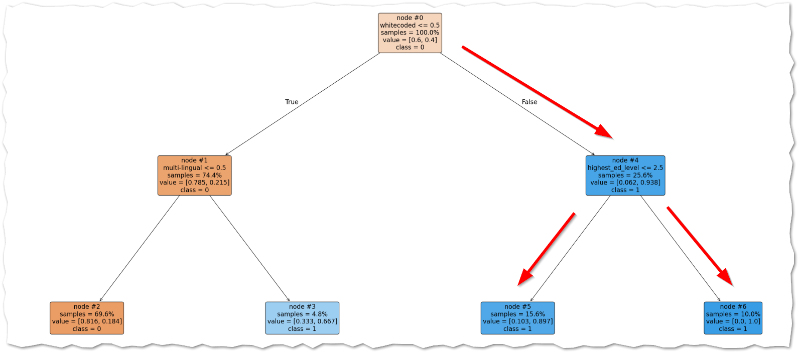
- According to this model, if you are coded as white (that is, whitecoded = 1) and if you have a person with an advanced degree in your home, then you have a 100% chance of getting a high score on the math test. If you are coded as white, and do not have any person in your home with an advanced degree, then you have a 89.7% chance of getting a high score on the math test.
- That’s a problematic model. There’s nothing about skin color that directly influences math aptitude. It’s also not very helpful to the Rochadelphia educators. Even if they wanted to, those educators can’t change the color of a person’s skin! The model is illogical and not helpful as it stands.
The fundamental idea here is that educators need to focus on concepts and skills that can be taught. For example: language can be taught, behaviors and habits can be formed, but other factors (for example, a person’s blood type!) are immutable.
- Now it is time to look for other variables that are correlated, positively or negatively, with the math test scores.
- Open and run the correlation_matrix notebook.
- Take note! Correlations are determined mathematically. All of the columns needed to be numeric. That means the columns_to_keep column only includes the numeric columns.
- Run the correlation matrix script and copy/paste the matrix image here.
<< your matrix goes here>>
- Now… think about it… looking at the matrix you generated what columns, other than those pertaining to race, have the most bearing on the math test score? List the top four in the box below.

- Of those four, which ones can the Rochadelphia educators influence the most?

- Let’s build a new decision tree model. Open up decision_tree2. (It is an exact copy of decision_tree) Edit the features list in cell 4, removing columns related to race and gender. We do not want to build an ML model using those features.
- Run the script. Copy/paste a screenshot of your new and improved decision tree.
<< your decision tree goes here>>
- Reflect. In the boxes below write several complete sentences about two examples of bias that were evident in this scenario. The scenario is imaginary, of course, but think of it as if it was real. Be sure to identify where you think the bias may have been introduced (data collection, data cleaning, model training, or evaluation) and what kind of bias it was (systemic, human or computational)
- Example 1

- Example 2

- When you are done, upload this Word document to the corresponding assignment on Canvas.

