Record Screen Capture
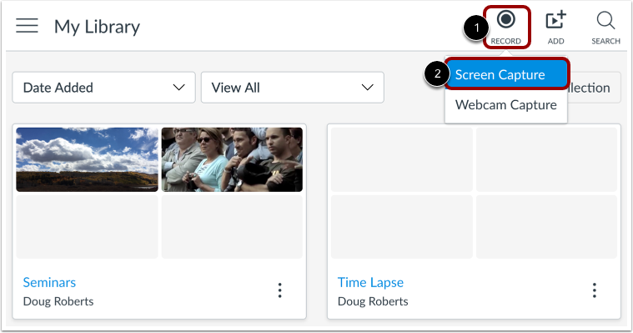
To record a screen capture go to Studio in your Canvas account, click the Record button [1] and then click the Screen Capture link [2].
Note: Screen Capture is not available on Chromebooks.

Download and Install Screen Capture Application
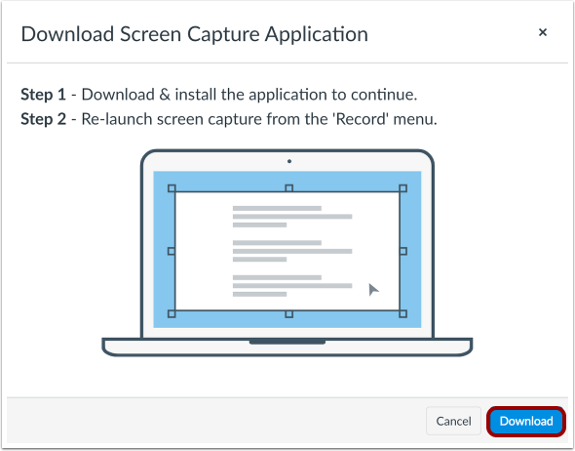
To record the screen, you will need to download and install the screen capture application. To download the application, click the Download button.
Note: If you have downloaded a different version of the screen capture application, uninstall the previous version and download the recent version from Studio.

Record Screen Capture
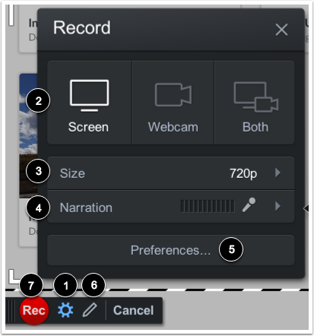
To manage recording settings, click the Settings icon [1]. You can also choose the type of recording [2], screen size [3], and narration volume [4].
To change your recording preferences, click the Preferences button [5]. The preferences you can change include the pause hotkey, webcam big hotkey, mark timeline hotkey, count down, control bar, webcam preview, fullscreen rec controls, reposition cursor on resume, and keyboard controls while paused.
To use the draw and zoom tools, click the pen icon [6]. The draw and zoom tools include lines, arrows, boxes, highlights, speech bubbles, and colors, etc.
To start the screen capture, click the Rec button [7].

Pause Screen Capture
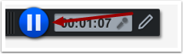
When the screen capture is done, click the Pause button.

Finish Screen Capture
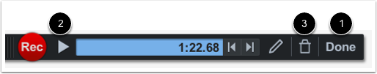
To upload the screen capture, click the Done button [1].To preview the screen capture, click the Play button [2]. To delete the screen capture and start over, click the Delete button [3].

Upload Screen Capture
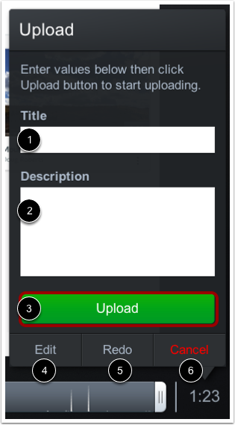
To upload the screen capture, enter a title [1], description [2], and then click the Upload button [3]. You can also edit the capture [4], redo the capture [5], or cancel the capture [6].

Return to Uploads
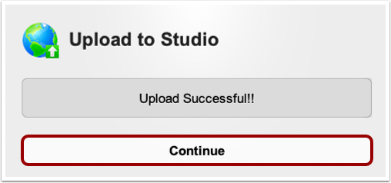
Click the Continue button.

View Screen Capture
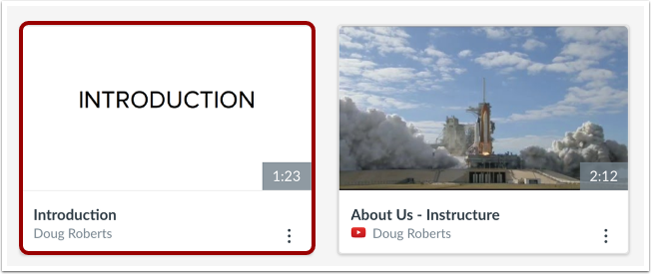
In the My Uploads page, view your screen capture. Once the screen capture is processed, you can manage all controls and settings.

Once done with your recording, in the assignment page select “More”, and then select Studio (you can then select your recording)

