Recording Your Screen for Assignments

Windows 10

Use PowerPoint
Step 1: With a PowerPoint file already open, click Insert on the menu bar followed by the Screen Recording button located on the Media panel to the far right.
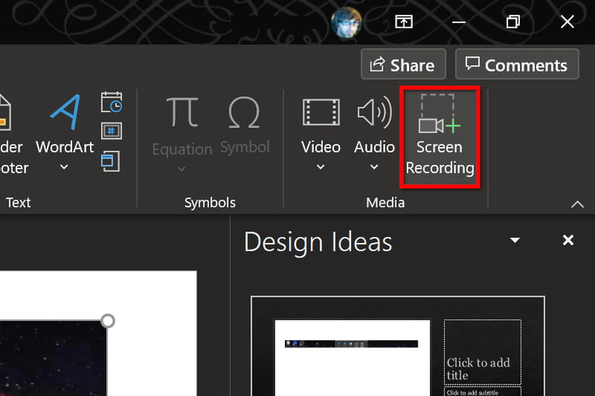

Step 2: The screen dims white and renders a toolbar along your screen’s top-center edge, as shown below. Click the Select Area button and use your mouse to draw a box around the area you want to record. The target area is then outlined with a red dashed line and devoid of the white transparency. Alternatively, press the Windows + Shift + F keys simultaneously to record the entire screen.
Step 3: Click the Record button or press the Windows + Shift + R keys simultaneously.
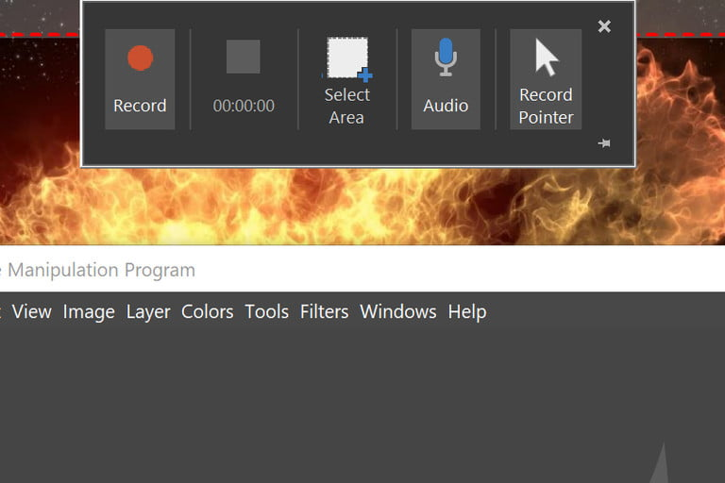

Step 5: You can click the Pause button — it replaces the Record button — to halt the recording as needed. Click the square Stop button to end the capture.
Step 6: To save the recording, right-click on the Video displayed within PowerPoint and select the Save Media As option on the pop-up menu. Follow the on-screen prompts to save your recording.
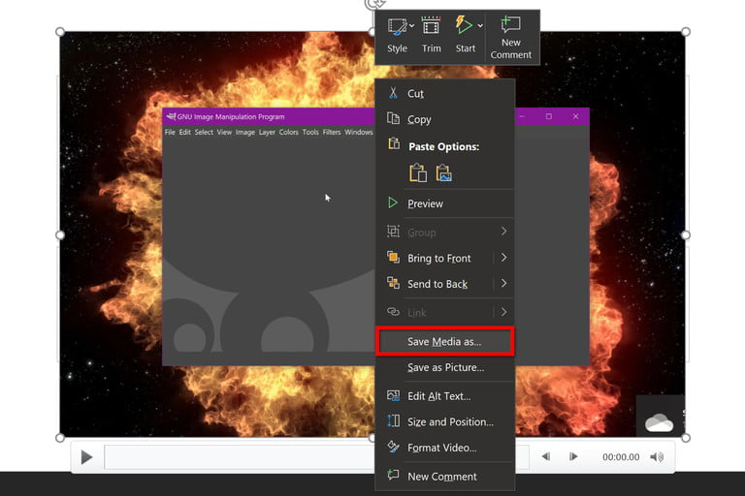
When you’re done, you can save the video as a separate file to access or embed as you see fit. Editing and control options are very limited after that, but it’s a great option for quick-and-dirty recording — especially if you’re doing it for a looming presentation.

Mac Users

Use the Capture Tool
Included with MacOS Catalina and newer is a native feature that allows you to record the screen and take screenshots. Here’s how:
Step 1: Press Shift + Command + 5 to bring up the screenshot toolbar.
Step 2: The toolbar appears on the screen with two sets of buttons: Three on the left to capture a screenshot and two in the middle for recording the screen. It also provides Options and Capture (or Record) buttons.
Click the Record Entire Screen button (left) or the Record Selected Portion button (right) followed by the Record button — it replaces Capture if the tool was originally in screenshot mode — located on the right.
Step 3: When done, click the little Record button located on the menu bar at the top of the display, as shown below. Alternatively, press Command + Control + Esc.
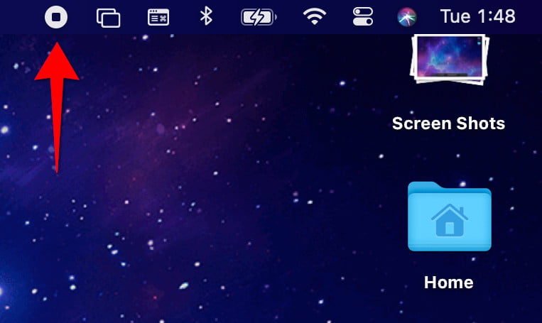
The video saves to the desktop by default.

