Nico DeSandre
Sentiment Analysis in Data Analytics
With the mass digitization of businesses and the prevalence of social networks, there is more raw qualitative data than ever to be analyzed. Much of this data can be accurately analyzed by Sentiment Analysis technology. Sentiment Analysis is the process of deriving human understanding from a piece of text such as the opinions or emotions the text conveys (Qualtrics). This is done through Natural Language Processing that assesses the sentiment of a particular piece of text and then groups it into categories such as “positive”, “negative”, and “neutral”. This information is invaluable to firms and individuals who need data on the feedback for their products or services. By analyzing vast amounts of text data such as reviews, social media comments, or survey responses faster than a human can, Sentiment Analysis delivers a comprehensive look at the general sentiment around various products, posts, or questions respectively.
When doing advanced analytics to derive information from collected data, Sentiment Analysis shines because it quantifies qualitative aspects. Using Advanced Analytics, one can use data from Sentiment Analysis to find statistically significant levels of negative or positive feedback from customers and react accordingly. For example, a significant level of negative reviews for a product could signify a product defect or consistent shortcoming of a product. Knowing this, a company can address these issues and in turn, increase customer satisfaction. This process is something that is intrinsic to advanced analytics as it allows for the gathering of business intelligence from raw data.
An example of Sentiment Analysis technology is IBM Watson Natural Language Understanding. This technology, known as Watson NLU, is a computing system that uses deep learning to understand the meaning and sentiment of text data (IBM). In an experiment, Monireh Ebrahimi from IBM used Watson NLU to read through car reviews and assign ratings on a scale of 1-5 based on the sentiment of said reviews. Compared to the actual ratings, Watson’s predictions yielded a correlation coefficient of 0.81, a score indicating strong correlation between the predicted scores and the actual scores (Ebrahimi). A figure of the results can be found below. These results demonstrate how accurate Sentiment Analysis can be. This accuracy is what makes Sentiment Analysis such a useful tool for Data Analytics as the world continues to become more and more digitized.
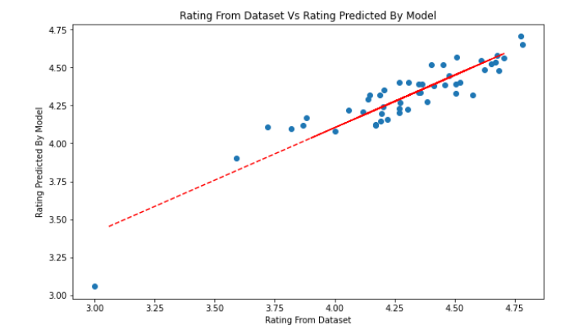

References:
Ebrahimi, Monireh. “Sentiment Analysis with Pandas and IBM Watson | by Monireh Ebrahimi | IBM Data Science in Practice | Medium.” Medium, IBM Data Science in Practice, 7 June 2021, https://medium.com/ibm-data-ai/sentiment-analysis-with-pandas-and-ibm-watson-1534a8557612.
“IBM Watson Natural Language Understanding | IBM.” IBM - United States, IBM, https://www.ibm.com/cloud/watson-natural-language-understanding. Accessed 10 Nov. 2021.
“Sentiment Analysis: Definition & Best Practices // Qualtrics.” Qualtrics, Qualtrics, https://www.qualtrics.com/experience-management/research/sentiment-analysis/. Accessed 10 Nov. 2021.

