Shaked Eldor
MIS 2502
Cloud Computing
Cloud Computing is a virtual delivery of on-demand computing services through the following four different models: (1) On-Premises (e.g. Private Cloud), (2) Infrastructure as a Service (IaaS), (3) Platform as a Service (PaaS), and (4) Software as a Service (SaaS) [1][2]. Currently, the most dominant Cloud Computing providers are Amazon (AWS), Microsoft (Azure), and Google Cloud [3][4]. Furthermore, cloud computing is important because it provides cost-effective, simple to manage, and reliable virtual computing services like Compute Engine, Storage, and Networking services [2] [3].
Through On-Premises, individuals can maintain their IT infrastructure onsite, such as running regular desktop applications (e.g. MySQL and RStudio) through their local network server [1][2]. Often times, large companies would utilize the method of an On-Premises private cloud to store and access large amounts of personal and private data [1][2]. For instance, institutions that have access to valuable data and thereby are more sensitive about the storage location of the data, such as the Banks’ access to customer data, can create an On-Premises private cloud in order to maximize the security of the data stored [2]. However, the development of such a high functioning on-site cloud infrastructure can be very expensive. The other three Cloud Computing methods are virtual, pay-as-you-go services that allow users to store and access their IT infrastructure offsite [1]. The primary difference between IaaS, PaaS, and SaaS is the services that the supplier provides and manages versus the services that the user manages. Through Infrastructure as a Service (IaaS), users can rent virtual computer hardware (e.g. servers and data center space) in order to manage and configure their applications and programs[1][2][3]. In addition, Platform as a Service (PaaS) allows users to create and develop their personal applications without needing to manage the underlying infrastructure[1][2][3]. Lastly, Software as Service (SaaS), allows users to connect to a cloud-based software, such as accessing a personal Gmail account through Google [1] [2][3].
The following graphic illustrates the different supplier-provided and user-managed services via IaaS, PaaS, and SaaS:

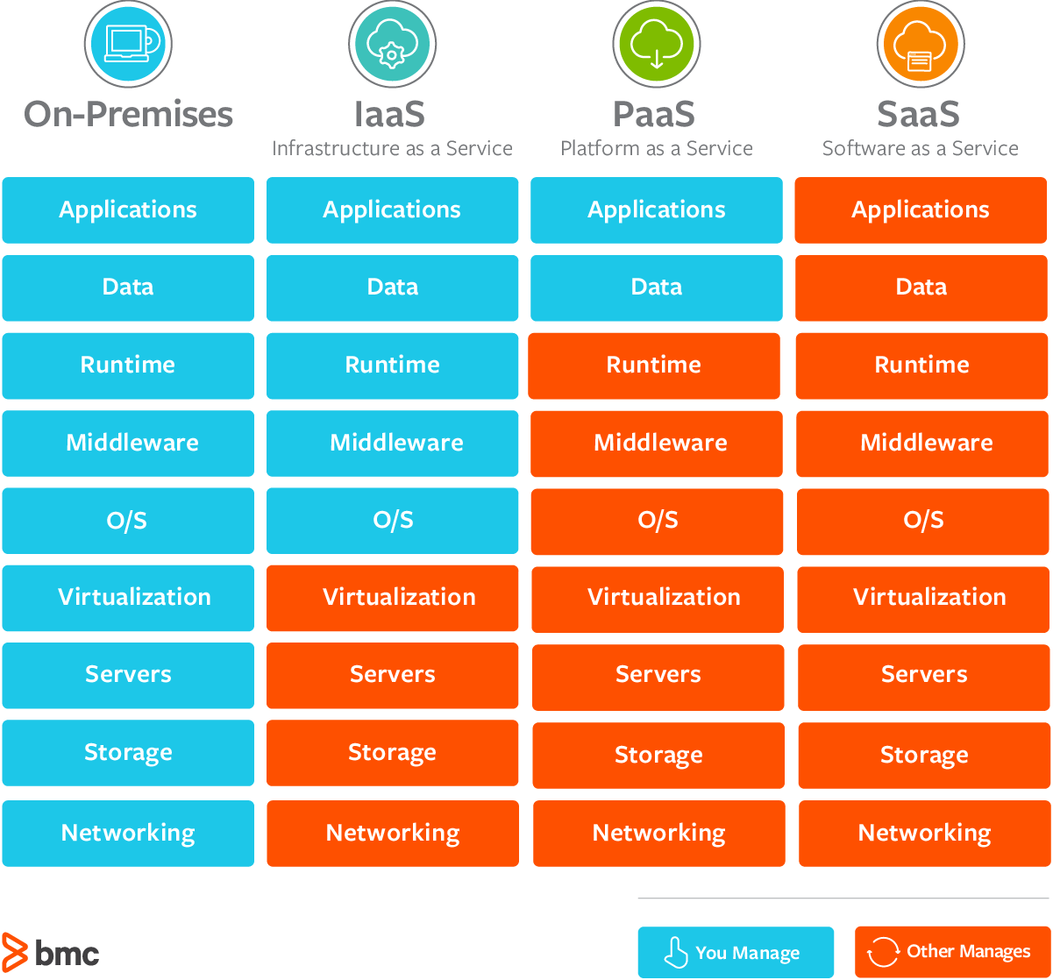 [3]
In regard to our MIS 2502 course, On-Premises personal computing was the primary method of use (e.g. downloading and installing MySQL, MongoDB, RStudio software to my personal computer). However, such applications can also be provided and accessed through PaaS. For example, Google Cloud Platform provides users with a MySQL database engine while handling patch management and database management such as upgrading, patching, and backups without user involvement to ensure high availability and performance.

References
[1] Ranger, Steve. “What Is Cloud Computing? Everything You Need to Know about the Cloud Explained.” ZDNet, ZDNet, 13 Dec. 2018, www.zdnet.com/article/what-is-cloud-computing-everything-you-need-to-know-about-the-cloud/
[2] “What is Cloud Computing?”, Amazon, Amazon Web Services, https://aws.amazon.com/what-is-cloud-computing/
[3] Watts, Stephen, and Muhammad Raza. “SaaS vs PaaS vs IaaS: What's The Difference & How To Choose.” BMC Blogs, 15 June 2019, www.bmc.com/blogs/saas-vs-paas-vs-iaas-whats-the-difference-and-how-to-choose/
[4]Dignan, Larry. “Top Cloud Providers in 2021: AWS, Microsoft Azure, and Google Cloud, Hybrid, SaaS Players.” ZDNet, ZDNet, 11 Jan. 2021, www.zdnet.com/article/the-top-cloud-providers-of-2020-aws-microsoft-azure-google-cloud-hybrid-saas/

